MINUTES
WildResearch Annual General Meeting 2023
Date: February 11, 2023
Location: VanDusen Gardens and online via Zoom (hybrid event)
Start: 6:00 PM (PST)
In Attendance:
In person: Vinci Au (President), Kiirsti Owen (Secretary), Viktorija Juciūtė (Treasurer), Alexandra Welch (Director-at-Large), Florian Reurink (Director-at-Large), Anneka Vanderpas (Director-at-Large), Ilian Vakarelov (MSOC), Emily Clark (MSOC), Alan McKenzie, Colby Delisle, Fiona McDonald, Jacob Aragones, Catherine Jardine, Jacelyn Shu, Angela Bond (Urban Raptor Committee), Jacob Ke, Kephra Beckett (MSOC), Siim Karu, Stefanie Miklosovic, Nicole Chin, Ian Thompson, Marina Thompson, Jillian Chiam, Darren Irwin, Alex Moore, Scott Wilson (MSOC), Liam Ragan, Sunny Tseng, Claudia Shaughnessy (MSOC), Brooklyn Hillman, Stewart Guy, Stephen Partington
Virtual: Quinn McCallum (Director-at-Large), Julian Heavyside (IIBO Committee), George Bowron, Murray Lashmore, Miki Eslake (EDI Committee), Trisha Beaty, Donna McKenzie
Regrets: Devin deZwaan (Director-at-Large), Sarina Clay-Smith (Director-at-Large), Myles Lamont (Director-at-Large), Matthias Bieber (Director-at-Large)

Welcome and introductions – Vinci Au
- Meeting was called to order at 6:00 PM
- Welcome: brief introduction to the hybrid version

Adoption of Agenda – Vinci Au
Motion: to adopt the agenda.
Moved by: Stephen Partington
Seconded by: Angela Bond
Decision: Motion carried unanimously

Approval of the minutes from the 2022 agm – Vinci Au
- Available at: http://wildresearch.ca/about-us/resources/
Motion: to approve the WildResearch 2022 AGM Minutes
Moved by: Allan McKenzie
Seconded by: Brooklyn Hillman
Decision: Motion carried unanimously

President’s report
- Presented by President – Vinci Au
- See Appendix A for the full report

Treasurer’s report
- Presented by Treasurer Viktorija Juciute
- See Appendix B for the full report

Committee Reports
- BCMMP presented by Florian Reurink (see Appendix C)
- COHA presented by Angela Bond (see Appendix D)
- MSOC presented by Viktorija Juciute (see Appendix E)
- IIBO presented by Matthias Bieber (see Appendix F)
- EDI presented by Kiirsti Owen (see Appendix G)

Elections
- The following are WildResearch members stepping down from the Board of Directors for 2023:
  - Director at Large: Paul Preston
  - Director at Large: Melanie Wilson

- The following are WildResearch members being nominated for the Board of Directors for 2023:
  - Vice President: Kiirsti Owen
  - Secretary: Anneka Vanderpas
  - Director at Large: Alexandra Welch

- The following are WildResearch members in good standing and are nominated for the positions listed on the Board of Directors for 2023:
  - President: Vinci Au
  - Treasurer: Viktorija Juciute
  - Director at Large: Florian Reurink
  - Director at Large: Myles Lamont
  - Director at Large: Devin de Zwaan
  - Director at Large: Quinn McCallum
  - Director at Large: Matthias Bieber
  - Director at Large: Sarina Clay-Smith

Motion: to approve the 2023 nominations for the WildResearch Board of Directors
Moved by: Catherine Jardine
Seconded by: Marina Thompson
Decision: Motion carried unanimously

Adjournment
Motion: to adjourn the 2023 Annual General Meeting
Motion carried unanimously

Appreciation awards
**Note to all members, please keep these new appreciation awards in mind for future years. Any and all members can nominate any other member who deserves recognition for their contributions to WildResearch!**

Please join us after the meeting for our 13th Annual Volunteer Appreciation Party!

APPENDIX A

WildResearch President’s 2022 Report
As I reflect on the past few years, I think about all the challenges and abrupt changes we’ve had to face as individuals, as an organization, and collectively as a species. Some things unfortunately divided us, but I think in many ways it brought us closer together and made us realize how important it was to take care of ourselves, our loved ones, our community, and our planet. As WildResearchers, we quickly evolved and adapted to the changes by adopting online formats, changing our protocols, and finding creative ways to connect from a distance. At the end of the day though, I think we all missed the connection of physically being together. I’m fortunate enough to have stepped into this role as President as we transition out of the pandemic and into a new future with new tools, fresh ideas, a renewed enthusiasm for conservation, and a new perspective on how to connect to nature and the people around us.
Along with new ideas come a great deal of work! All our dedicated volunteers worked tirelessly to get new programs off the ground, expand our reach, and provide more value for our members and conservation science. The Membership Services and Outreach Committee (MSOC) continued to provide online workshops, like the “How to get into graduate school” workshop with Kephra Beckett, but we also started to offer more in-person options again. We also had our very first Beach Clean-up & Brunch event at Third Beach in Stanley Park—drawing mostly people who have never heard of WildResearch, bird banding, or citizen science before. We introduced a field excursion to the Tilbury Island were Dominic Janus, a Master’s student at UBC, talked about the impacts of Canada Geese on the Fraser River Estuary. We offered a guided mushroom ID walk with Aril Yeo, the President of the Mycological Society. We opened our Winter Bird ID walks to members of the public so more people can learn about and appreciate the birds all around us; in response, we’ve had our largest turnouts ever with approximately 30 people in attendance at each walk! MSOC was also able to secure funding to purchase binoculars and a new scope for our bird ID walks so new birders don’t have to have buy their own. With the input from our Equity, Diversity, and Inclusion (EDI) Committee, we’ve now started a membership bank where a portion of our funding will go towards free memberships that anyone can claim. We’ve also included an option for new and renewing members to contribute to this membership bank. This year, MSOC has increased public access to our programs and lowered barriers to community science. I know they will continue to take small and steady steps towards a more equitable future for WildResearch and conservation.
The members of our EDI Committee continue to provide Diversity and Inclusion training for all new board members and committee chairs. They also initiated a new Code of Conduct for IIBO and are determined to increase inclusivity at WildResearch—especially with underrepresented groups.
Our migration monitoring program at Iona Beach Regional Park is the cornerstone of WildResearch. It provides opportunities for young career biologists to learn, then teach, and ultimately lead at a banding station. This year our volunteers contributed over 1300 hours of service at the station alone and captured 5316 birds. Banders-in-Charge, Banding Assistants, and volunteers at IIBO also introduce members of the public to conservation science and the wildlife in their own backyard this popular and publicly accessible park; this year we welcomed 600 visitors to the banding station. In cooperation with MSOC, the IIBO Committee held a hands-on Beginner Banding Workshop for 19 new trainees in the spring. This committee is small and mighty, but it is not immune to the challenges that plague many charitable organizations: capacity. Unfortunately, our much-anticipated Northern Saw-Whet Owl banding program had to be postponed due to lack of capacity in 2022 but we’re hopeful we can launch this new program in 2023. There will also be significant changes in the years to come at Iona as the wastewater treatment plant (WWTP) will be undergoing a massive upgrade that includes environmental restoration of the park. After monitoring the area for 12-years, we are well positioned to observe changes in bird abundance, fitness, and habitat use as the WWTP and the surrounding area changes over time. A big shout-out to our IIBO Program Manager, Matthias Bieber, as well as our Banders-in-Charge and Banding Assistants: Brendan Toews, Quinn MacCallum, Julian Heavyside, Angela Bond, Chloe Boynton, Sean Vanderluit, and Claudia Shaughnessy, for all the amazing work that they do!
Our BC Marsh Monitoring Program (BCMMP) in collaboration with Birds Canada continues with great success. In this second year, the program conducted a total of 158 surveys across the Lower Mainland and the Fraser Valley. With the help of incredibly dedicated volunteers with Sky Jarvis and Tay Powrie, the program has been able to expand and grow in the Thompson-Nicola region. Many thanks to our BC MMP Program Manager, Florian Reurink, for all his hard work!
The Cooper’s Hawk (COHA) Survey is also experiencing great success with their surveys. With Angela Bond leading, we had 19 of 24 quadrats surveyed and 2022 had the second highest participation rate of COHA surveys ever! Looking forward to the future, we’re hoping to streamline and digitize data entry for these surveys.
As a Board, we’ve been spending a lot of time thinking about how we can provide more value to conservation science, invite more people into the conservation space, and train more community scientists and budding conservationists. The last year was dedicated to reflecting deeply and considering different ways to grow the three pillars of WildResearch: research, outreach, and training. We’re developing a research committee that could coordinate collaboration efforts with government institutions, universities, and other organization, making our volunteer efforts that much more meaningful and impactful while providing more training opportunities for our members. We’ve already seen what an impact we made when we published a decade’s worth of data collected at IIBO by our volunteers and with the WESA project in collaboration with Environment and Climate Change Canada, and we’re looking forward to many more research-forward initiatives. Many thanks to Devin de Zwaan who is spearheading this effort! I want to thank all the board members who served with me over this past year: Kiirsi Owen, Viktorija Juciūtė, Anneka Vanderpas, Myles Lamont, Paul Preston, Devin de Zwaan, Florian Reurink, Quinn MacCallum, Alexandra Welch, and Sarina Clay-Smith; your time, thoughtfulness, and passion inspire me always.

APPENDIX B

WildResearch Treasurer’s Report of 2022 Finance
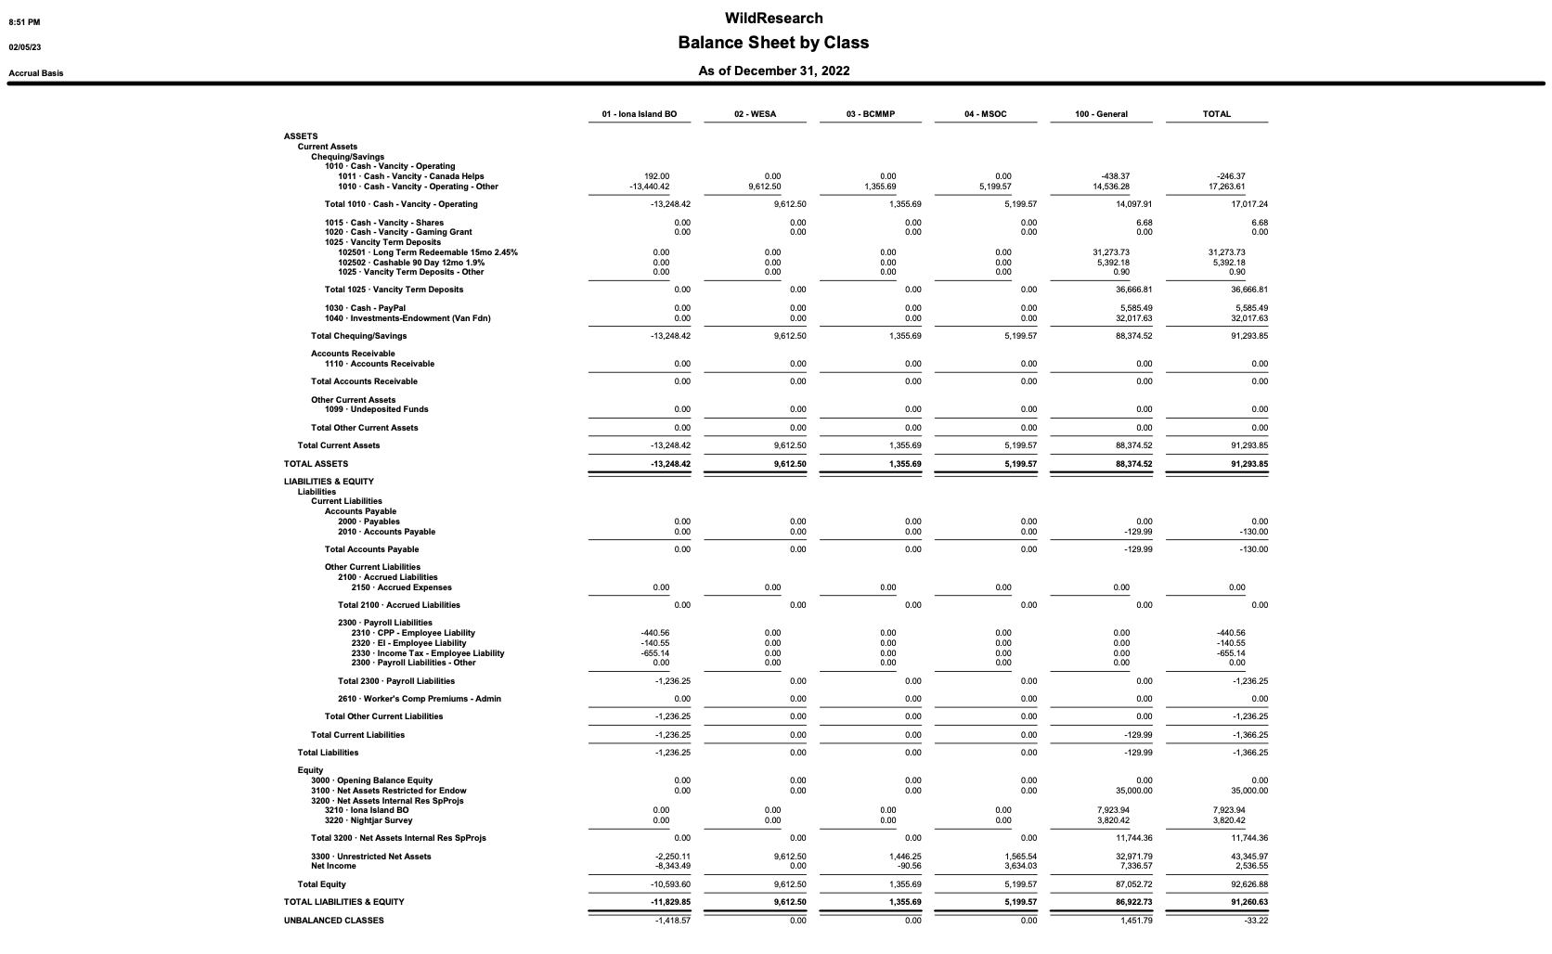

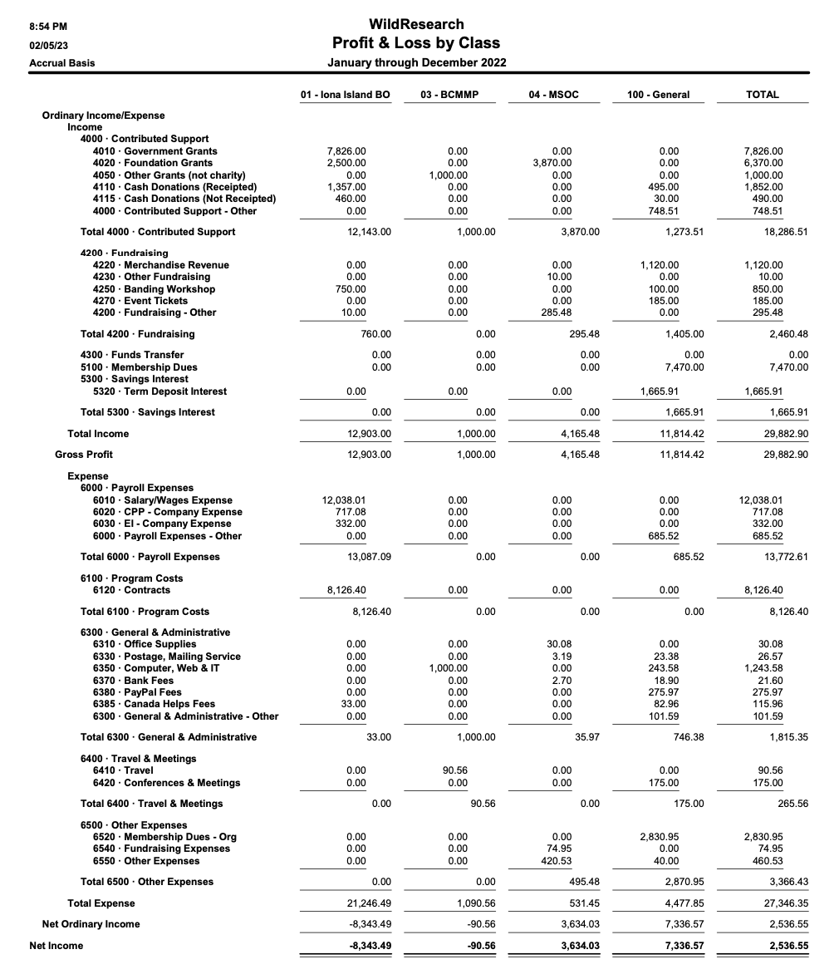

APPENDIX C

British columbia marsh monitoring program (BCMMP) 2022 REport

C.1 Program Goals
The BCMMP contributes to all 3 organizational goals:
- Contribute to conservation science: The BCMMP collects presence and abundance data on 13 amphibian and 8 marsh-dependent bird species in wetlands throughout the Lower Mainland, Fraser Valley, and Thompson-Nicola region, with plans to expand throughout the rest of BC. All monitored amphibian and bird species rely on marsh habitat to breed. Some amphibian species are highly endangered, while others are invasive. Data from the BCMMP is shared on the NatureCounts data portal from Birds Canada and is made available to interested parties upon request for use in research and to inform conservation efforts.
- Provide our members and partners with training and education in conservation science: The BCMMP provides volunteers with the skills to conduct passive call surveys for amphibians and targeted call-playback surveys for birds. Survey protocols, a recording of the training workshop, and resources for learning how to identify amphibians and target bird species by call or song are all freely available through NatureCounts that were designed and presented by BC MMP committee members.
- Conduct conservation outreach: The BCMMP conducts outreach and education through a newsletter, which is sent out on a monthly basis throughout the survey period from March until July, and bimonthly during the offseason. Furthermore, by combining bird and amphibian surveys, the BCMMP acts as a way for birders to learn about amphibian species in BC.

C.2 Season successes
Things that went well this season (2022):
- In the second year of the BCMMP, volunteers conducted 90 amphibian surveys and 68 bird surveys in 20 marshes throughout the Lower Mainland and Fraser Valley.
- The Habitat Joint Ventures conducted 356 bird surveys across BC, with an additional 5 bird surveys from BCWF.
- The marsh bird survey protocol has been updated to standardize surveys across the BCMMP, Habitat Joint Ventures (Canada & US) and Puget Sound Bird Observatory in British Columbia and Washington State.
- The amphibian survey handbook and protocol has been updated to clarify and simplify the survey timing and species identification. Birds Canada updated the online data entry form for amphibians to match the bird data entry form and allows for incidental observations of non-target amphibians and reptiles.
- Birds Canada has integrated the BCMMP survey station adoption into NatureCounts so that volunteers can manage their stations through an interactive map online.
- The BCMMP expanded to the Thomson-Nicola region with help from Sky Jarvis and Tay Powrie taking on coordinating roles for the region.
- Kanu Varman has joined the BCMMP as Grant Committee Representative to focus on grant writing for the BCMMP as well as supporting the WildResearch grant committee with grant applications.

C.3 Season challenges
Things that did not go as well this season (2022):
- Although there is still an interest for our program, and only few volunteers left the program, the BCMMP did not receive many new volunteers in 2022. Funding for outreach and promotion is needed to recruit more volunteers in 2023.
- Continuing from last year all survey forms needed to be reviewed and validated manually by BCMMP committee members. Because this requires considerable time and effort the committee was unable to finish the data review in 2022. Funding is needed to hire someone to do this work for the BCMMP in 2023.

C.4 Summary of events
March 3 – BCMMP 2022 Season Update
BCMMP 2022 Season Update was held over Zoom with approximately 30 participants. The workshop was free to attend and consisted of a half an hour program and survey update from Florian Reurink (WildResearch), blake danis (WildResearch) and Remi Torrenta (Birds Canada). Participants were presented with the 2021 survey results, lessons learned from the 2021 surveys and updates to the 2021 survey protocols.

March to July – Survey Period
BCMMP volunteers continued surveys from 2021 and established a few additional survey stations. Three amphibian surveys, two bird surveys, and a habitat assessment were conducted throughout the season at each survey station. Volunteers conducted surveys on their own schedules based on the BCMMP protocols. After conducting their surveys, volunteers uploaded their observations to the BCMMP NatureCounts portal.

January - December – BCMMP Committee Meetings
BCMMP Committee members met every last Tuesday of the month to discuss program ideas and task to continue and expand the program. This included survey protocol and handbook updates, collaborations with Habitat Joint Ventures, Rivershed Society of BC, and BCWF, program promotion and program expansion, funding opportunities.

C.5 Program Improvements & Future Outlook
The bird survey handbook has been updated to include the American Coot to replace the Yellow Rail as a target bird. This was done in collaboration with Habitat Joint Ventures (Canada & US) and the Puget Sound Bird Observatory to standardize the survey protocols across BC and Washington State. In addition, volunteers are asked whether they were able to record at least 90% of the additional birds present by sight, song or call such that the data becomes more comparable across experience levels.
The amphibian survey handbook has been updated with the expected distributions of various amphibian species to avoid the potential misidentification of species not known to be found in surveyors’ geographical areas. The online data entry form for amphibians was also adjusted to match the online data form for birds and allow for entry of non-target amphibian and reptile species.
The survey adoption process has been automated in NatureCounts so that volunteers no longer have to adopt a station through an email with the BCMMP committee, and the BCMMP committee no longer have to manage volunteers and their stations manually. Volunteers can now simply go to an interactive online map to see which stations are available and select any of the available stations for adoption. Once a station has been adopted it can no longer be adopted by other volunteers. If a volunteer decides to leave the program they can simply retire from their station, which makes the station automatically available again for adoption.
The BCMMP has expanded to the Thompson-Nicola region where Sky Jarvis and Tay Powrie have taken on a coordinating role. Several new survey stations have been established and several efforts have been made to promote the program in the region. The BCMMP Lower Mainland and Thompson-Nicola collaborate on continuing and expanding the program across BC.
Kanu Varman has joined the BCMMP as Grant Committee Representative. As Grant Committee representative Kanu helps the BCMMP with searching for funding opportunities and applying for grants. The BCMMP is in need of funding to expand the program furthermore, so having a dedicated grant writer is a big step forward for the BCMMP.

Future ideas for the BCMMP are mostly funding dependent and include:
- Hiring a survey data reviewer
- Organizing marsh excursions
- Inviting experienced guest speakers to share their knowledge with the BCMMP committee and volunteers
- Participating in local events to promote the BCMMP
- Using promotional materials like posters, banners, flyers, stickers, or pens to promote the BCMMP

C.6 Funding this past year
NA

C.7 Budget for next year
Income
2023 BCMMP Account Balance  Anticipated Funding | $1446.25  $2050
Total | $2496.25

Expenses
Employee to review survey data | $2050
Total | $2050

C.8 Volunteer hours
Volunteer surveyors: ~72 hours
BCMMP Committee members: ~400 hours

C.9 Personnel/Committee members
BCMMP Committee: Florian Reurink, blake danis, Sarah Town, Harrison Smith, Sky Jarvis, Tay Powrie, Kanu Varman.
Former(F)/Inactive(I) BCMMP Committee: Quinn McCallum (F), Jessie Russell (I), Gordon Hatusupy (I)
Birds Canada: Catherine Jardine, Rémi Torrenta

C.10 Collaborations
The BCMMP is itself a joint effort between WildResearch and Birds Canada. Birds Canada provides the protocols from the Great Lakes MMP upon which our protocols are based, our NatureCounts portal, liability insurance for our volunteers, and organizational support. The BCMMP would not be possible without Birds Canada.
The BCMMP collaborates with various local naturalist groups throughout BC, who conduct surveys at their sites using our protocols and submit their data to the project. These groups include the Stanley Park Ecology Society and the Wild Bird Trust.
In addition, BCWF and Habitat Joint Ventures are using the BCMMP bird survey protocols for surveying secretive marsh birds across BC. The BCMMP, Habitat Joined Ventures Canada and US and Puget Sound Bird Observatory also collaborated on updating the marsh bird survey protocol such that data could be compared across BC and Washington State.

APPENDIX D

Cooper’s Hawk (COHA) RAPTOR MONITORING PROGRAM 2022 REport

D.1 Program Goals
The Raptor Monitoring contributes to all 3 organizational goals:
- Contribute to conservation science: The data collected from the raptor monitoring program allows for changes in environmental conditions throughout the lower mainland to be observed by using a key indicator species of urban raptor, the Cooper’s Hawk (Accipiter cooperii).
- Provide our members with training and education in conservation science: The raptor monitoring program trains participants in how to conduct raptor surveys using protocols used by government and industry. The pre-season workshop provides educational material about the importance of the environmental pollutants and the effects on wildlife.
- Conduct conservation outreach: By providing this program to the general public, the raptor monitoring program shares with its participants the need for monitoring which will then be shared with their friends. As the surveys are completed throughout the urban area, occasionally people will stop to ask about the purpose of the call play-backs, providing more educational opportunities in real time.

D.2 Season successes
Things that went well this season:
- Our program had good volunteer participation this year. Fourteen people surveyed this season (this is the second highest participation rate we’ve had so far). Five volunteers surveyed more than once; one volunteer completed three quadrats.
- There was great coverage of quadrats this season. A total of 19 out of 24 possible quadrats (79%) were surveyed.
- There were a good number of COHA reported (11 confirmed positive responses plus a few potentials), plus a couple detections outside survey times between survey stations. Four of the quadrats had 2 COHA detections reported in them.

D.3 Season challenges
Things that did not go as well this season:
- Communication was an ongoing issue this season. My time was very limited this past year and I didn’t have time to follow-up as often as I would like. It took a long time to track down the data this season, and at the time of this report I am still waiting for one dataset. Two quadrats that were assigned to volunteers but were not completed were not known they were not going to be completed until the end of season. I expect this to be better next season.
- Eleven volunteers from 2021 did not repeat their participation this season, which is a much higher rate than usual (some moved way, some not available, some not interested). But we were able to pick up a fair number of new volunteers to help cover this.
- We didn’t have any sort of post-season thank you gathering or gift this year. We haven’t done this any year but should try to implement going forward.

D.4 Summary of events
- The main orientation was on March 19 with six people in attendance. A second orientation was held on April 2 with three volunteers in attendance. Both orientations were in person this year, and we had a positive audial COHA detection during the second orientation! Surveys were conducted between March 27 and April 24.

D.5 Program Improvements & Future Outlook
- I am working with one of our volunteers on a more streamlined way to report data; either by using an online database or through a cell phone app. More information on this to come.
- The following three points are carrying over from the previous year:
  - We would like to plan on having each quadrat surveyed twice per season – on any two different days within the survey period. This would not need to be done by the same person necessarily. One quadrat was surveyed twice this season. We will need to determine how best to implement this.
  - We would like to start implementing some degree of nest monitoring of known active nests, but still need to plan out what this will look like.
  - We would like to implement a post-season thank you event or gift for the volunteers that participated.

D.6 Funding this past year
- The program didn’t use any funding this year.

D.7 Budget for next year
- The board approves a budget of $200 per year for this program to use for volunteer appreciation. I have yet to confirm if this is the case this year; however the COHA program has not used this annual budget yet.

D.8 Volunteer hours
- Approximately 85 hours for station set-up, survey completion, and data entry.

D.9 Personnel/Committee members
- The Program Co-Managers are Jay Brogan and Angela Bond, and there are no other committee members.

D.10 Collaborations
- No collaborations this year.

APPENDIX E

MEMBERS SERVICES AND OUTREACH COMMITTEE 2022 REport

8 Members:
Viktorija Juciute, Newsletter Contributor, Memberships Coordinator
Vinci Au, Board Representative
Colin Macfarlane, Newsletter Coordinator, Newsletter contributor
Chloe Boynton, Member at Large
Kephra Becket, Social Media Liaison
Scott Wilson, Member at Large
Ilian Vakarelov, Member at Large
Emily Clark, Member at Large

Sadly, we said goodbye to Jacqueline Huard (congratulations on your growing family!), and Marina Thompson. We gladly welcomed three new members to our committee; Scott, Ilian and Emily.

E.1 Committee Purpose
The Membership Services and Outreach Committee (MSOC) is all about the members! We manage the administration of members, events, and communication to members. WildResearch’s current membership as of December 2022 stands at 202 active members.

The MSOC oversees:
- Membership (registration, payment, insurance),
- Organizing the AGM & the Volunteer Appreciation Party (VAP),
- Merchandise,
- Fundraising,
- Outreach and general advertising,
- Newsletter production,
- Social media management and posting, 202
- Some e-mails/contact liaisons with members, and
- Planning, organizing and facilitating official WildResearch events and workshops.

E.2 2020 Committee Accomplishments
It has been another successful year for the MSOC. This year, in total we estimate that we raised $5,100.00 from events, donations, and general membership. We held 12 MSOC meetings, ran the newsletter, social media, conducted targeted and general outreach, and hosted or planned 9 events with participation by well over 145 people (total). GO MSOC!
AGM
Similar to past years, the MSC successfully planned and orchestrated the previous AGM (2022) on February 26th, our first ever AGM that was held both digitally and in person. This year’s AGM & VAP will follow a similar format (online and in person), and will also be held at VanDusen Gardens on Feb 11th, 2023.
Outreach
- Newsletter – This year we, again produced 32 newsletters with the help of 5 creators. Each newsletter requires 2 people to produce. Colin Macfarlane was the Newsletter Lead, and along with contributors Viktorija, Jillian, Alexandra and Brooklyn, we were able to consistently produce quality newsletters week in, week out. We look forward to incorporating some new ideas in the new year.

- Social Media – our presence has continued to increase with the ongoing help of Kephra, Hannah, Vinci, Viktorija, and Ilian! We are now reaching:
  - Facebook: 1,934 Followers/1,826 likes
  - Twitter: 1,281 Followers;
  - LinkedIn: 229 Followers; and
  - Instagram: 2,096

- Demographics Survey – This survey was delivered to our members last February, and was well received by our members, with excellent participation! The survey yielded some interesting results- some of which suggested members were encouraged by the direction WildResearch was going, while others suggested areas where we could be more inclusive, or new avenues of interest we could explore.
We look forward to publishing these results shortly!

Events
We held 9 events this year:

- Socials have begun again! We have hosted one social, and are excited to keep them coming!
- Iona Island Bioblitz (822 observations of almost 200 species, made by 46 observers)
- Mushroom ID Walk with Aril Yeo(8 attendees - $55 raised)
- Spring Bird Walk, May 7th, Led by Chloe Boynton (10 attendees)
- Goose Impacts Field Trip to Fraser River Estuary with Don Janus (4 attendees)
- Beach Cleanup, between 2nd and 3rd Beach (17 attendees)
- Graduate School Workshop with Kephra Beckett (6 attendees, $40 raised)
- The 2022/2023 Guided Bird Walks have gone ahead
  - Dec 11th Led by Courtney Lahue at Burnaby Lake (23 attendees, $180 raised)
  - Jan 15th Led by Chloe at Terra Nova Rural Park (32 attendees, $195 raised)
  - Feb 18th Led by Florian at Trout Lake Park (24 attendees, $50 raised)
  - March 25th Led by Chloe at George C. Reifel Bird Sanctuary

E. 3 Volunteer time – 437 hours
This year due to the numerous events we facilitated, we hosted a meeting every month for a total of 12 this year (12 in 2020, 11 in 2021).
Regular Meetings: 12 meetings @ 1.5 hours each with 6 people ~ 100 hours
Non-meeting Outreach planning/organizing/delivering: ~15 hours
AGM planning/prepping outside of meetings: 25 hours
Social Media: 12 hours/month (spread across 3 people) ~144 hours
Newsletter: 2 hours/week for 32 weeks * 2 people + training time ~ >128 hours
Processing memberships: 1.5 hours/month * 2 people ~ 25.5 hours
Total estimated hours: 437 hours (459 in 2020, 369 in 2021)

E. 4 Finances
The total budget allocated to the MSC in 2022 was $200.00, and expenses have been much lower, due to a slow ramping up of social events, as we all return to pre-pandemic normals.

Total Spent: $3,955.45
- Venue rental: $509.25
- Food and drink: $446.20
- Zoom Account: $100
- Event honorariums/gifts: $100
- Optics for bird walks: ~$2,800

Recuperated costs: $5,100
- Merchandise: $995
- Events: ~$235
- 25 X 25 Grant: $3,870

E.5 Next Steps
The primary focus of the MSOC over the next 12 months include planning and executing the 2023 AGM and planning our spring events (See Table 1 below).
Table 1: Proposed 2023 WildResearch Events
Month | Count | Events
Jan | 1 | Guided Bird Walks,
Feb | 4 | Guided Bird Walks, AGM/Speaker/Trivia, Backyard Bird Count, Pub Speaker Series/Socials
March | 3 | EDI/MSOC collab Meeting, Guided Bird Walks, Socials
April | 3 | Spring Banding, Intro to banding, Cooper’s Hawk MP
May | 2 | Spring Banding, Global Big Day
June | 1 | Beach Cleanup
July | 0 | TBD
Aug | 1 | Garlic Fest
Sept | 1 | Fall Banding
Oct | 2 | Fall Banding, Vancouver Bird Week
Nov | 0 | TBD
Dec | 2 | Giving Tuesday, CBC
Total | 20 events!!

E.6 Challenges
As with all years, this was a year requiring high commitment levels from all members of MSOC, however, not necessarily higher than any other year. Members have done an admirable job of planning the AGM, all the while continuing to produce quality newsletters, posting on social media, updating membership numbers, sending emails, and continuing to run events like the Winter Bird ID walks. There has been continued turnover of members, however, new members have been bringing great energy, for which we’re all grateful!
There is always enough work for more members, so we are certainly happy to welcome new folks, which would allow us to further delegate tasks, and ease the workload of current members.
Having received input from general WR membership through the questionnaire last year, an exciting challenge for MSOC this year will be to incorporate some of these suggestions and ideas into MSOC programming.

APPENDIX F

IONA ISLAND BIRD OBSERVATORY (IIBO) 2022 REport

F.1 Program Goals
IIBO contributes to all 3 organizational goals.
- Contribute to conservation science: IIBO determines the abundance and diversity of migrants that use the Iona Beach Regional Park (hereafter: Iona) as a stopover site; IIBO monitors the arrival dates of spring and fall migrants and the departure dates of birds that migrate north to breed or south to overwinter.
- Provide our members with training and education in conservation science: IIBO provides a positive learning environment for volunteers, encouraging the developing of field ornithology skills (e.g. species ID, banding, extraction from nets).
- Conduct conservation outreach: To maintain a focus on public education and outreach on avian conservation via on-site demonstration and social media.

F.2 Season successes
Breakdown of # of species and individuals caught
Total # of birds captured: 5316 (4401 banded, 689 recaps, 242 unbanded)
- Spring:
  - 3836 total captures: 3260 banded, 350 recaps, 226 unbanded (mostly hummers)
  - Over 42 days (5 weather days); 1680.41 net hours
    - ~ 91.3 birds/day
    - 2.28 birds/net hr
  - Compared to previous years
Year | Total Captures | Birds/net hr
2015 | 1476 | 0.58
2016 | 1232 | 0.44
2017 | 2806 | 1.43
2018 | 2197 | 0.66
2019 | 2858 | 0.92
2020 | N/A | N/A
2021 | 1771 | 0.72
  - 55 species banded and 32 species recaptured
  - Most abundant banded:
Species | Number Banded
WIWA | 922
AUWA | 401
MYWA | 389
UYWA | 344
YEWA | 189
RCKI | 167
  - Interesting Highlights
    - Rarities: REVI
    - Other good birds: 3 VATH, BTYW, TOWA, PISI, 4 NAWA, 3 BUOR
- Fall:
  - 1480 total captures: 1141 banded; 339 recaps; 16 unbanded
  - Over 41 days (3 weather days); 1842.5 net hours
    - ~85 birds/day
    - 0.79 birds/net hr
  - Compared to previous years:
Year | Total Captures | Banding Days | Birds/net hr
2015 | 1476 | 22 | 0.35
2016 | 1232 | 22 | 1.05
2017 | 2806 | 29 | 1.12
2018 | 3509 | 35 | 0.95
2019 | 4192 | 38 | 2.02
2020 | 2272 | 37 | 1.03
2021 | 2448 | 29 | 1.62
- 44 species banded and 24 species recaptured
- Most abundant banded:
Species | Number Banded
YEWA | 343
FOSP | 82
COYE | 75
OCWA | 75
SOSP | 74
RCKI | 69
  - Interesting highlights
    - Rarities: HOWR, NOWA, RBSA, 5 WTSP
    - Also BTYW, FLIN
Breakdown of volunteer contribution and visitors
Total # of volunteers and volunteer hours:
- Spring: 40 different volunteers, 106 volunteer days, 751.5 hours
- Fall: 36 different volunteers, 103 volunteer days, 638.5 hours
- More hours than 2021 and 2020
Education & Outreach Program
- Total: 600 (Spring: 312, Fall: 288) people visited IIBO
- Group visits:
  - Spring: Beginner Banding Workshop, two second grade school groups – 77 people total
  - Fall: Wings Over Iona, UBC undergraduate ornithology class, UBC Wildlife Society Club, Kwantlen Polytechnic University group – 157 people total
Banding Workshops
Beginner Banding Workshop
- 19 participants at our April 15th beginner banding workshop.
Other Exciting Things
WildResearch Iona Island BioBlitz on iNaturalist
  - August 27 – October 7, 2022
  - 45 observers, 181 identifiers, 1477 identifications, 290 species, 821 observations
  - Most observed species:
Species | Number observations
Tanacetum vulgare | 12
Zonotrichia leucophyrs | 11
Melospiza melodia | 10
Gaillardia pulchella | 10
Bembix americana | 10
Rhionaeschna multicolor | 10
NSWO Monitoring Program
- NSWO banding in October postponed due to lack to capacity in 2022.

F.3 Season challenges
- Hiring new banders – high turnover with banding assistants
- Funding for salary is on ongoing challenge
- Getting intermediate/ advanced and census volunteers and to help, especially in fall when busy
- Coyote tampering with birds in net during fall
- Need more support with program management to advance the program
- One battery for solar panel died – Julian replaces with one of his own for now

Suggestions for how program can be approved (in correspondence to the 3 bullet points above):
- Start looking for banders earlier, advertise to broader audience
- Involve grant committee in fundraising, continue working with BC Nature to achieve recurring funding
- More advertisement on social media, email reminders to skilled volunteers, ask BC Nature volunteers for help with census
- Monitor for signs of coyote in spring, disseminate coyote awareness info, look into more serious hazing techniques if problem persists
- Find more members with time and enthusiasm to join the program committee
- Purchase new battery in spring

F.4 Other matters

2021 grants received:
- Canada Summer Jobs (Service Canada) – $10,734
- BC Nature - $2500

What’s going on in 2023
- Spring and fall banding seasons, banding workshops (covid allowing)
- NSWO Fall Monitoring and MOTUS tagging

Expenditures for 2022
- Total Salary: $21,182.21
- Spring
Employees | Amount | Contractors | Amount
Brendan Toews | $5280.66 | Julian Heavyside | $2240.00
Quinn MacCallum | $3615.15 | Angela Bond | $976.50
 |  | Chloe Boynton | $434.00
Total | $8895.81 |  | $3650.50
- Fall
Employees | Amount | Contractors | Amount
Brendan Toews | $4160.00 | Sean Vanderluit | $3380.40
 |  | Claudia Shaughnessy | $1095.50
Total | $4160.00 |  | $4475.9

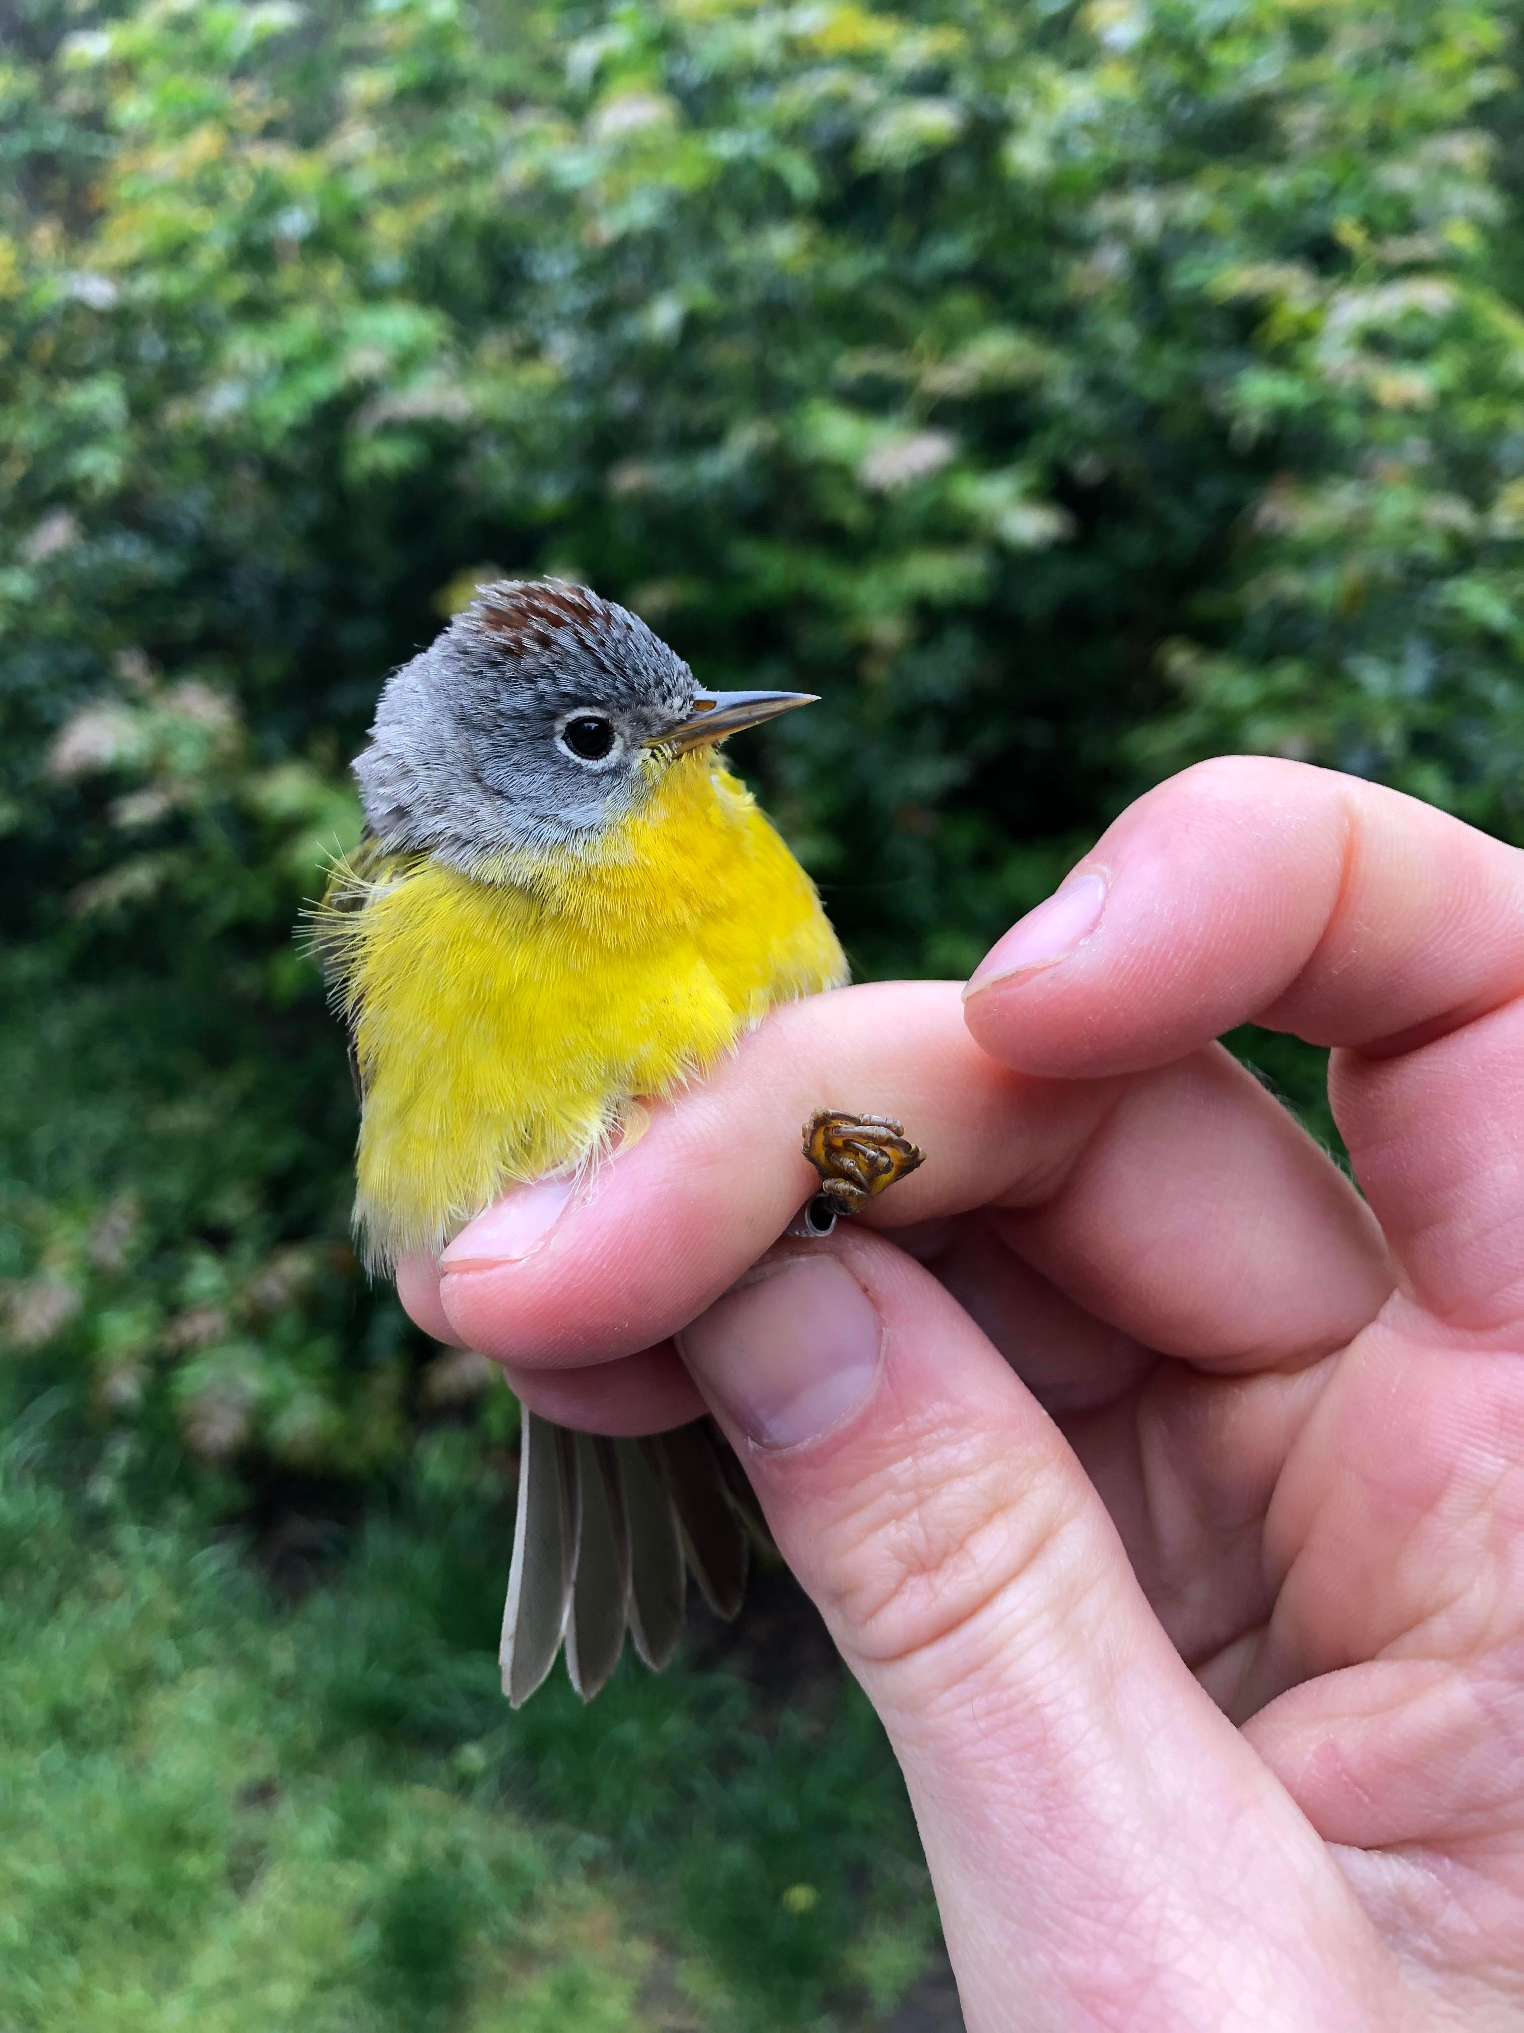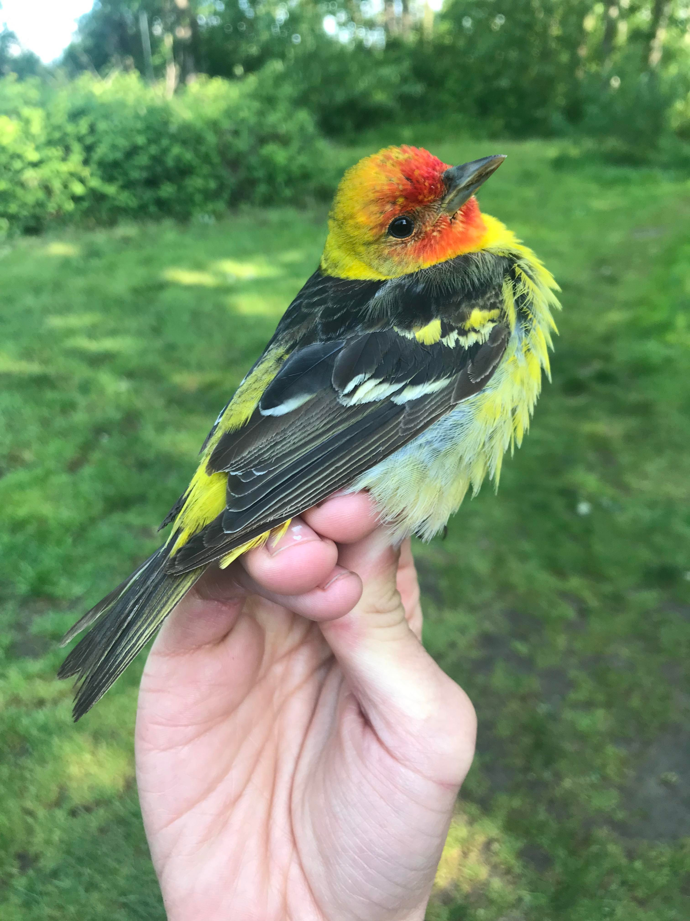
Nashville Warbler (NAWA) and Western Tanager (WETA). (Photo credits: Brendan Toews)

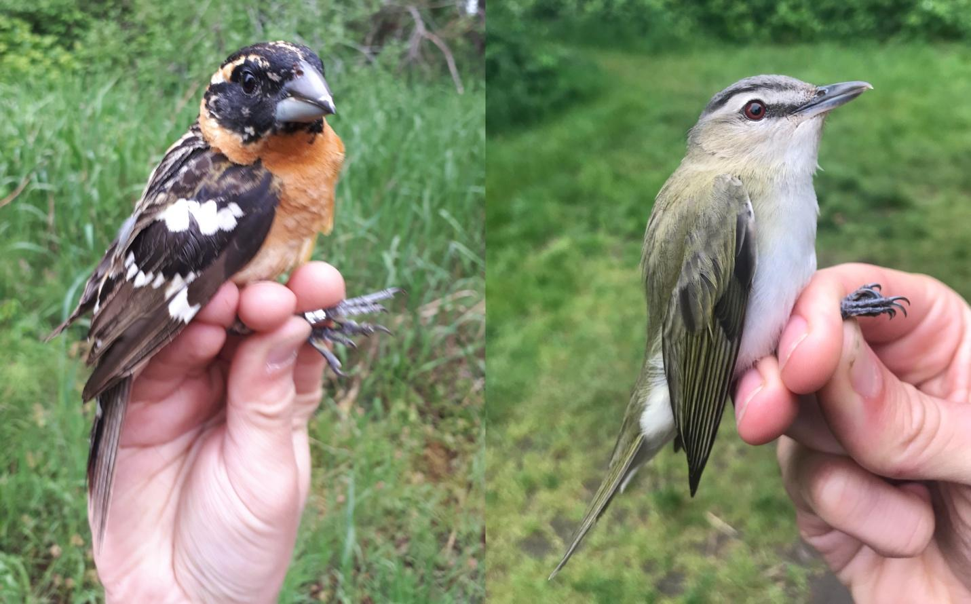
Black-headed Grosbeak (BHGR) and Red-eyed Vireo (REVI). (Photo credits: Brendan Toews)
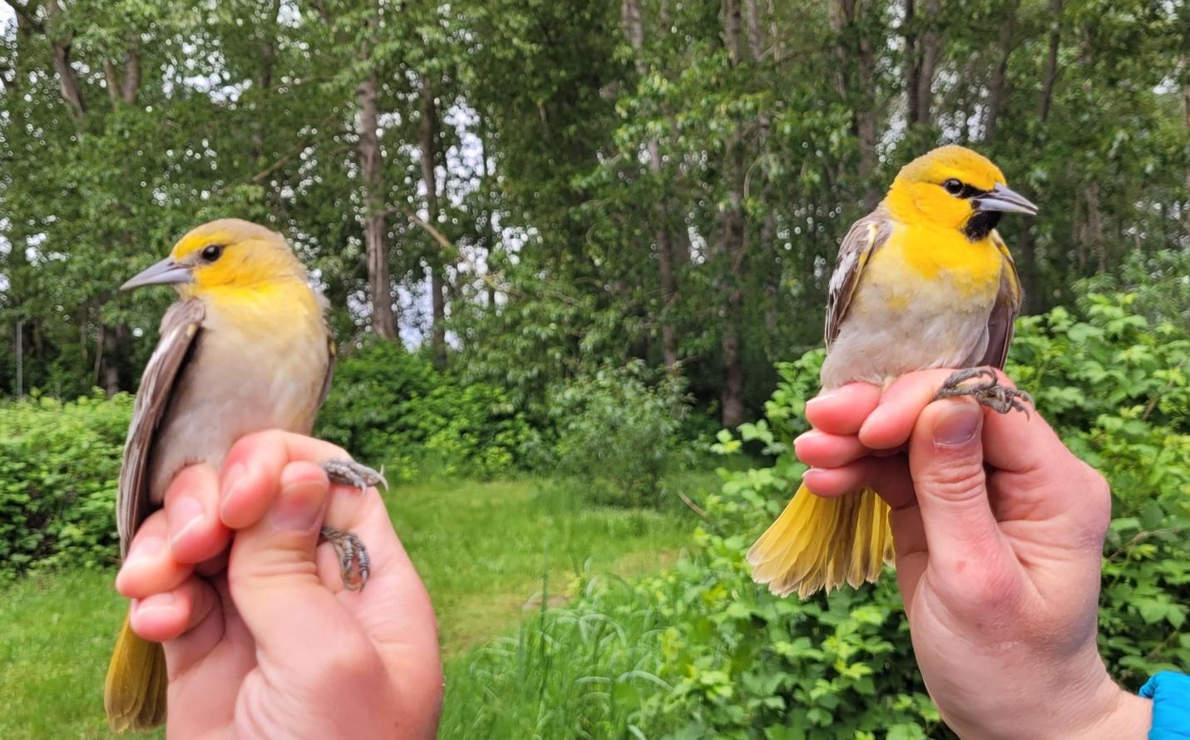
Female (left) and male (right) Bullock’s Orioles (BUOR). (Photo credits: Chloe Boynton)

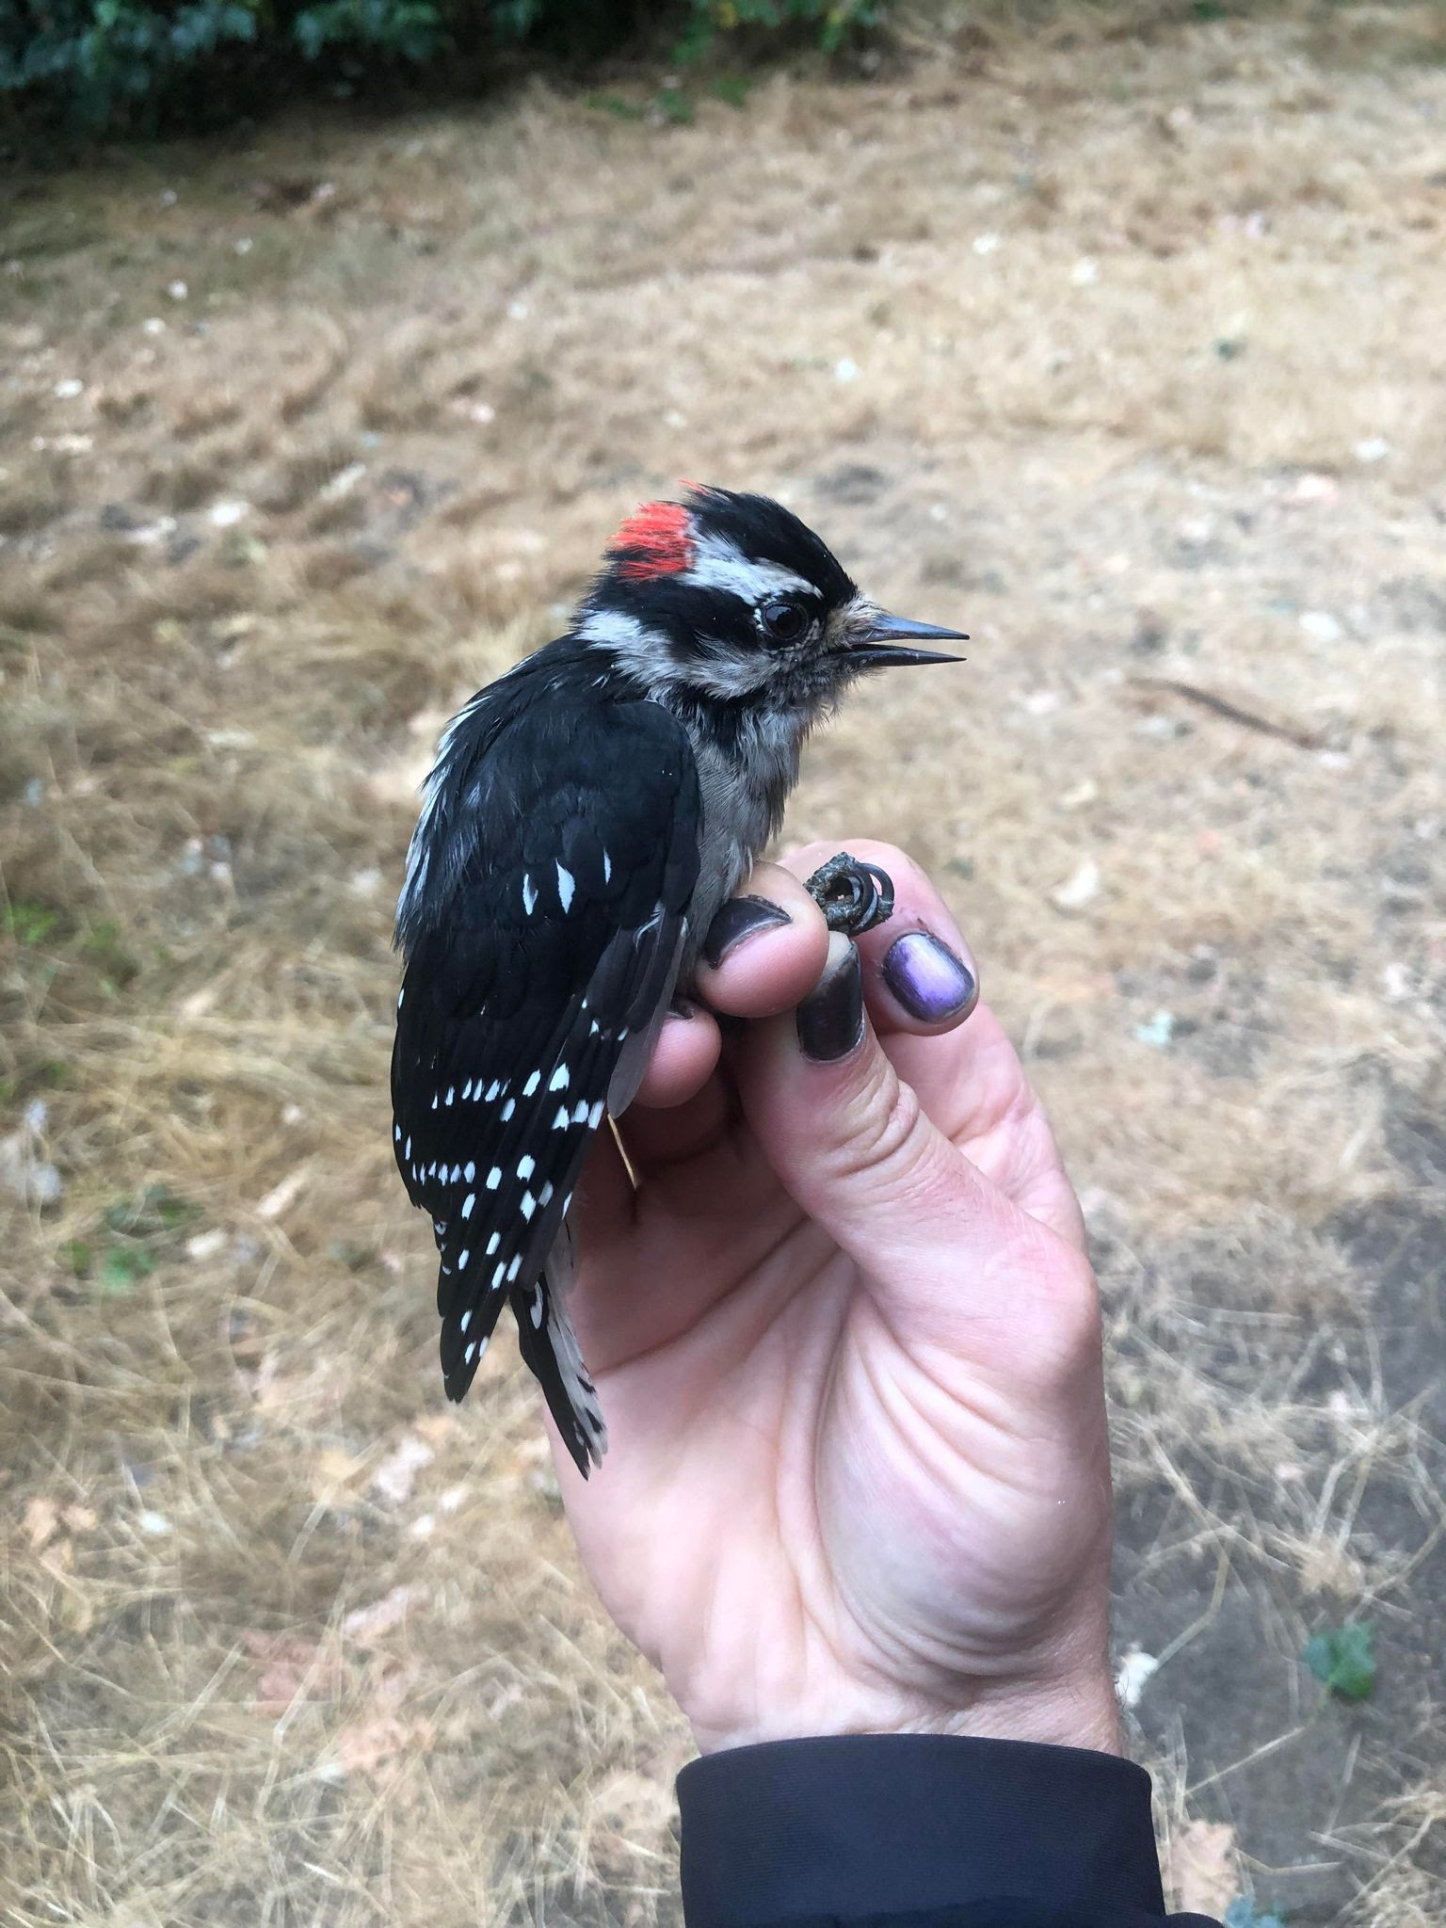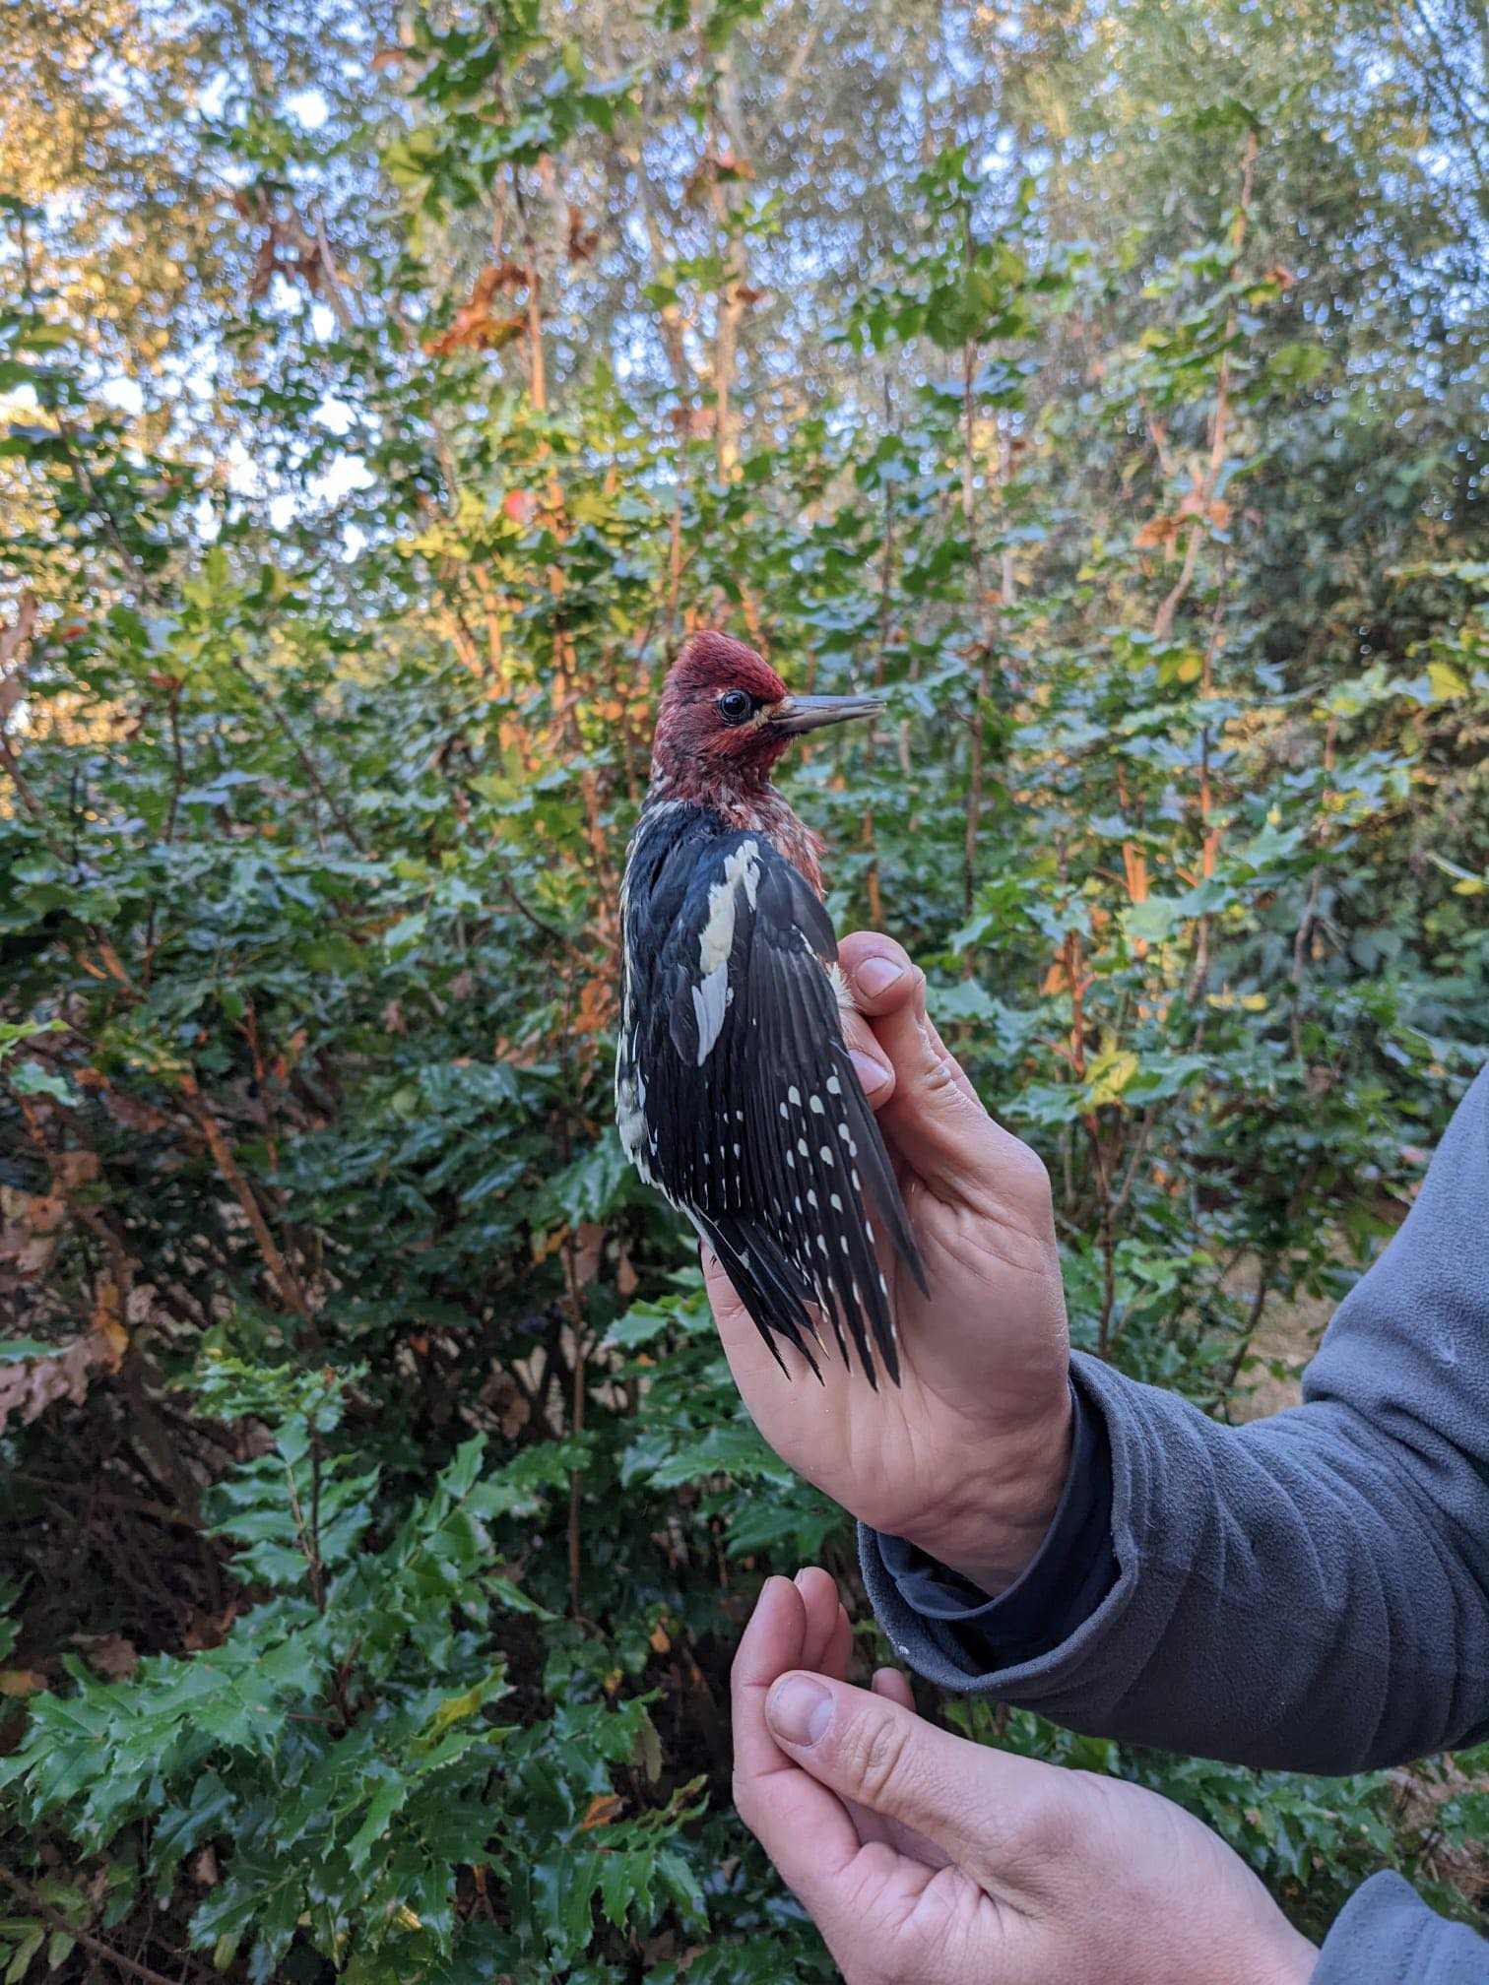
Downy woodpecker (left, DOWO) and Red-breasted Sapsucker (right, RBSA). (Photo credits: Julian Heavyside (DOWO), and Claudia Shaughnessy (RBSA))
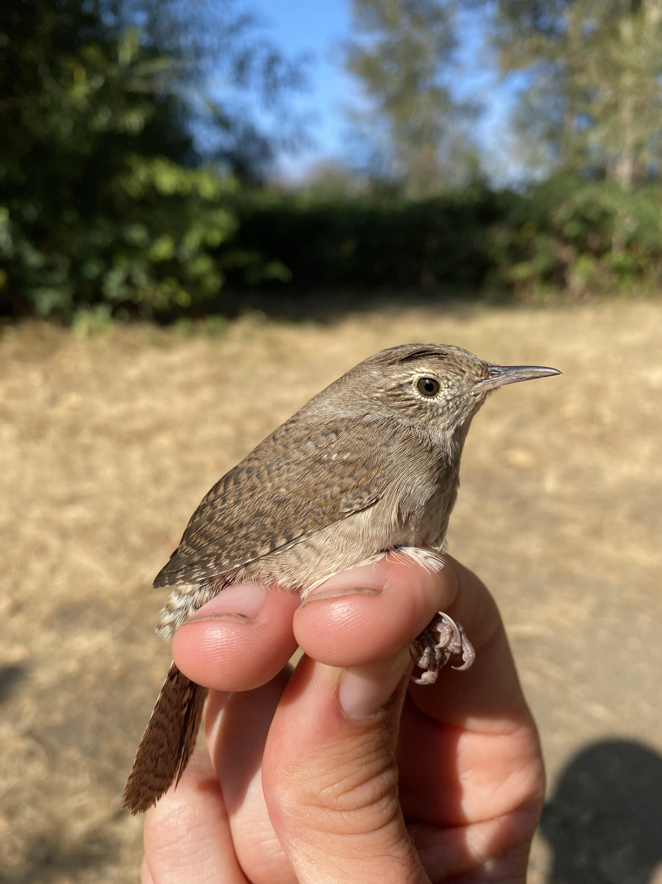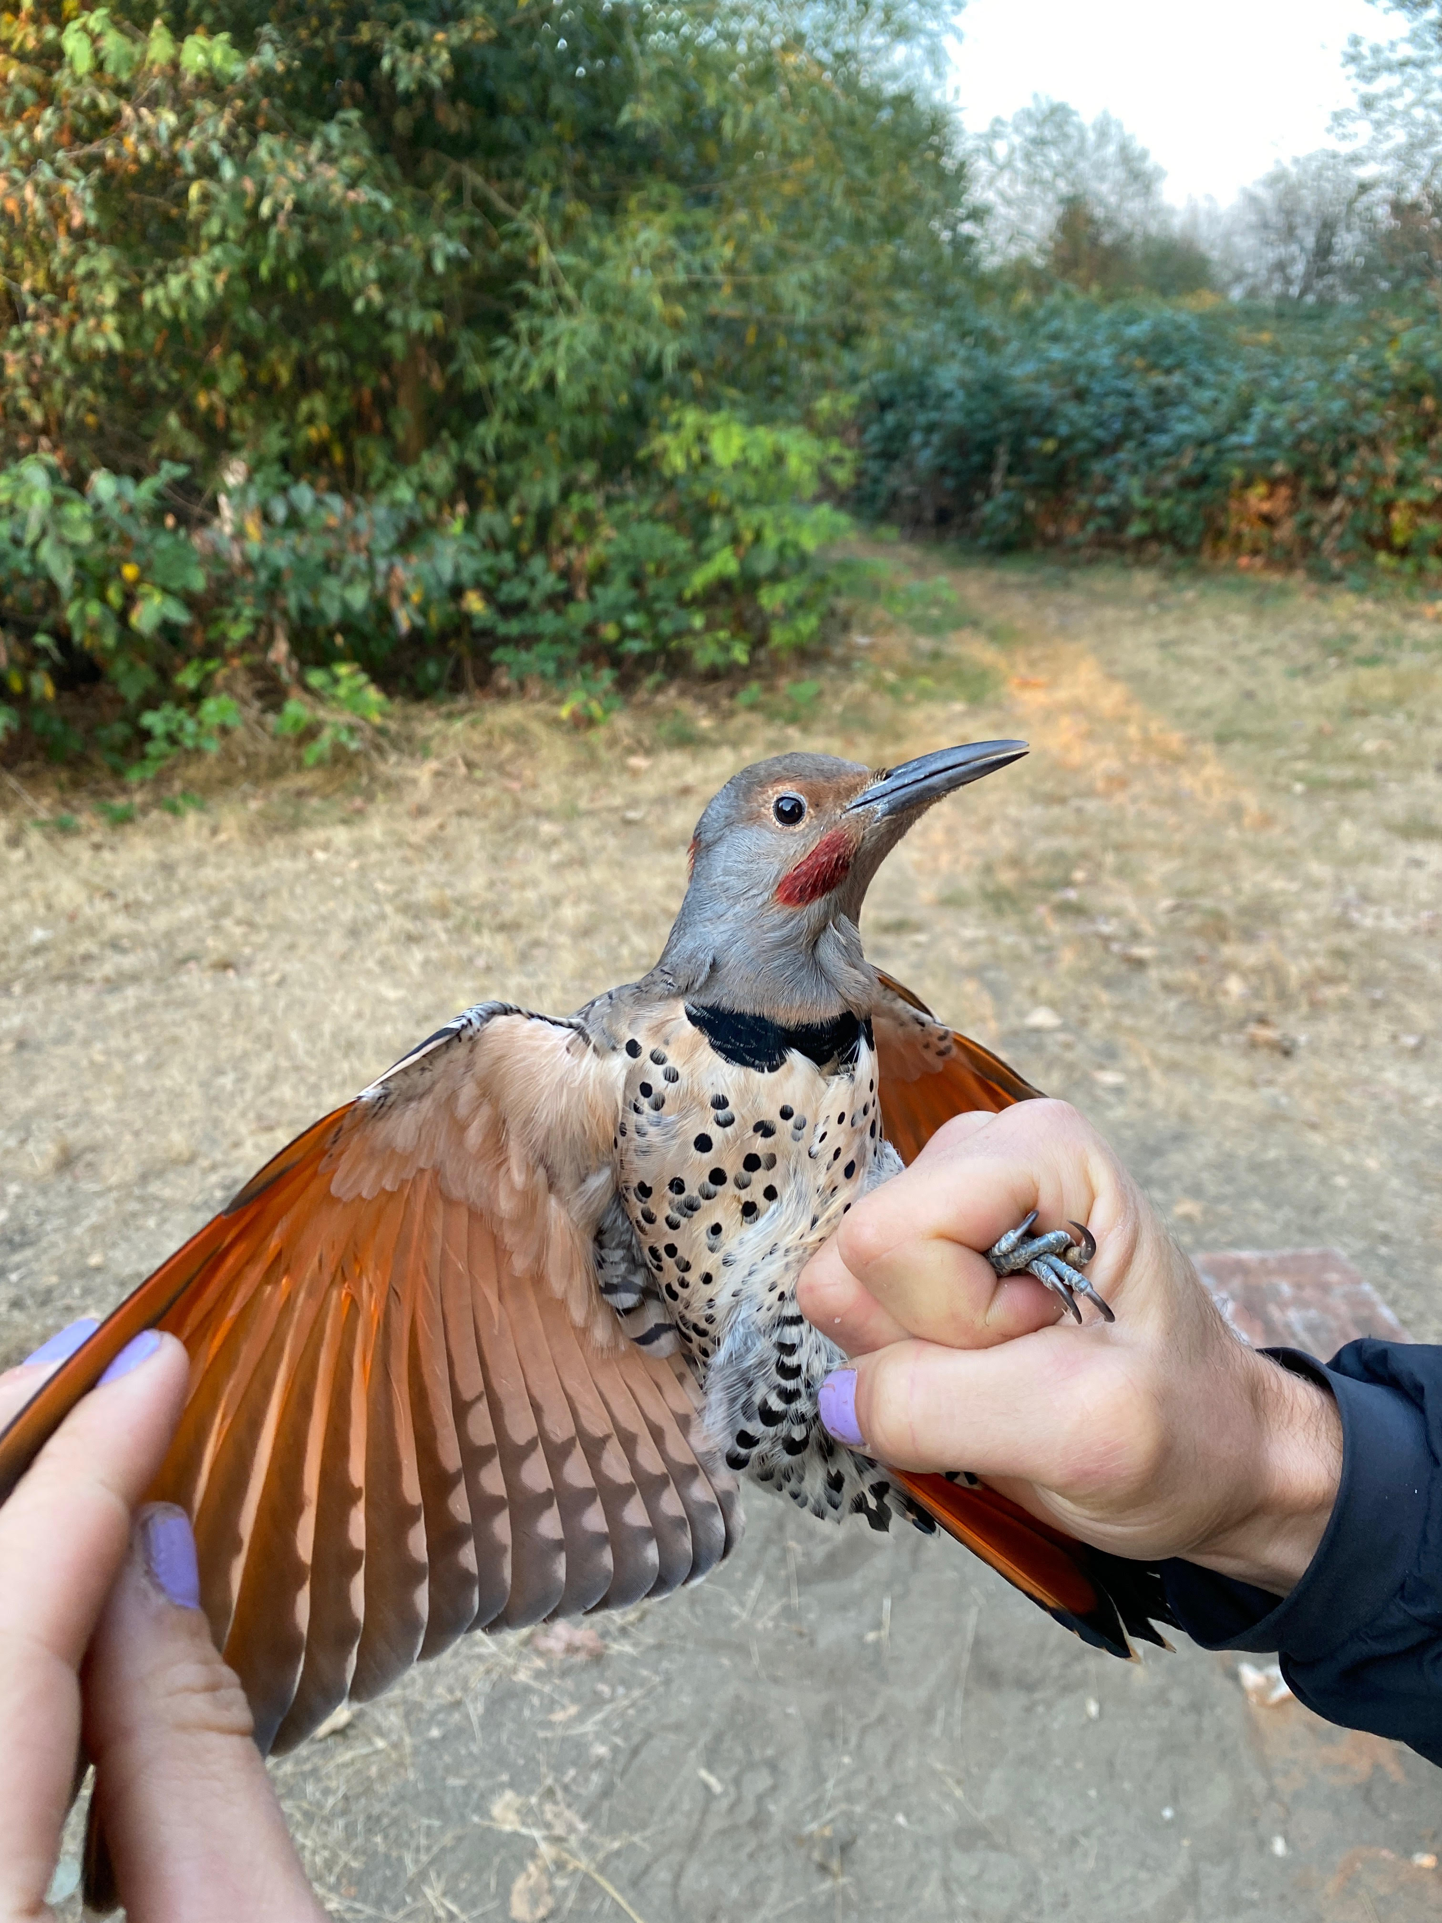
House Wren (HOWR, left) and Northern Flicker intergrade (right, FLIN). (Photo credits: Sean Vanderluit)

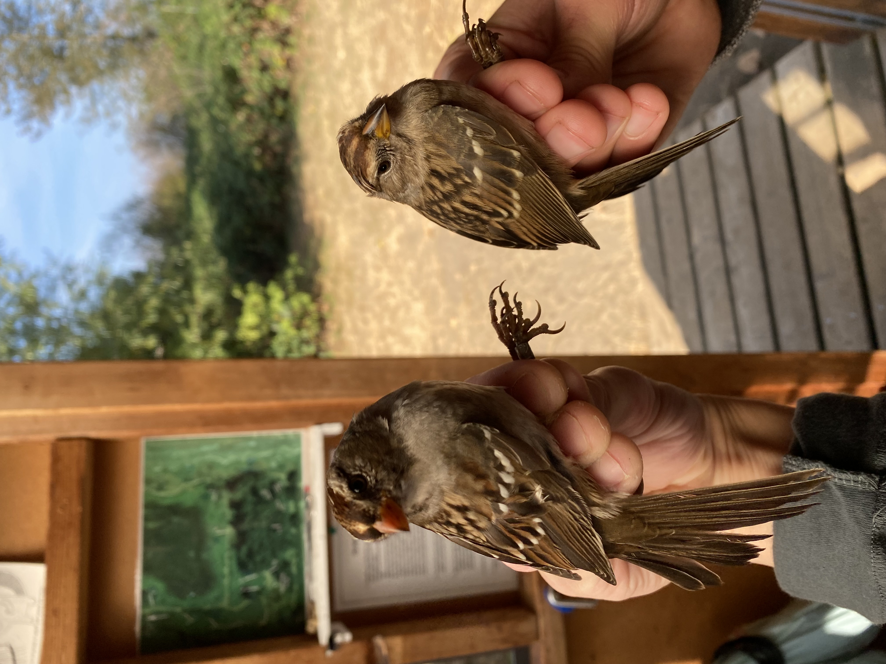
Gambel’s White-crowned Sparrow (GWCS, left) and Puget Sound White-crowned Sparrow (PSWS, right). (Photo credits: Sean Vanderluit)

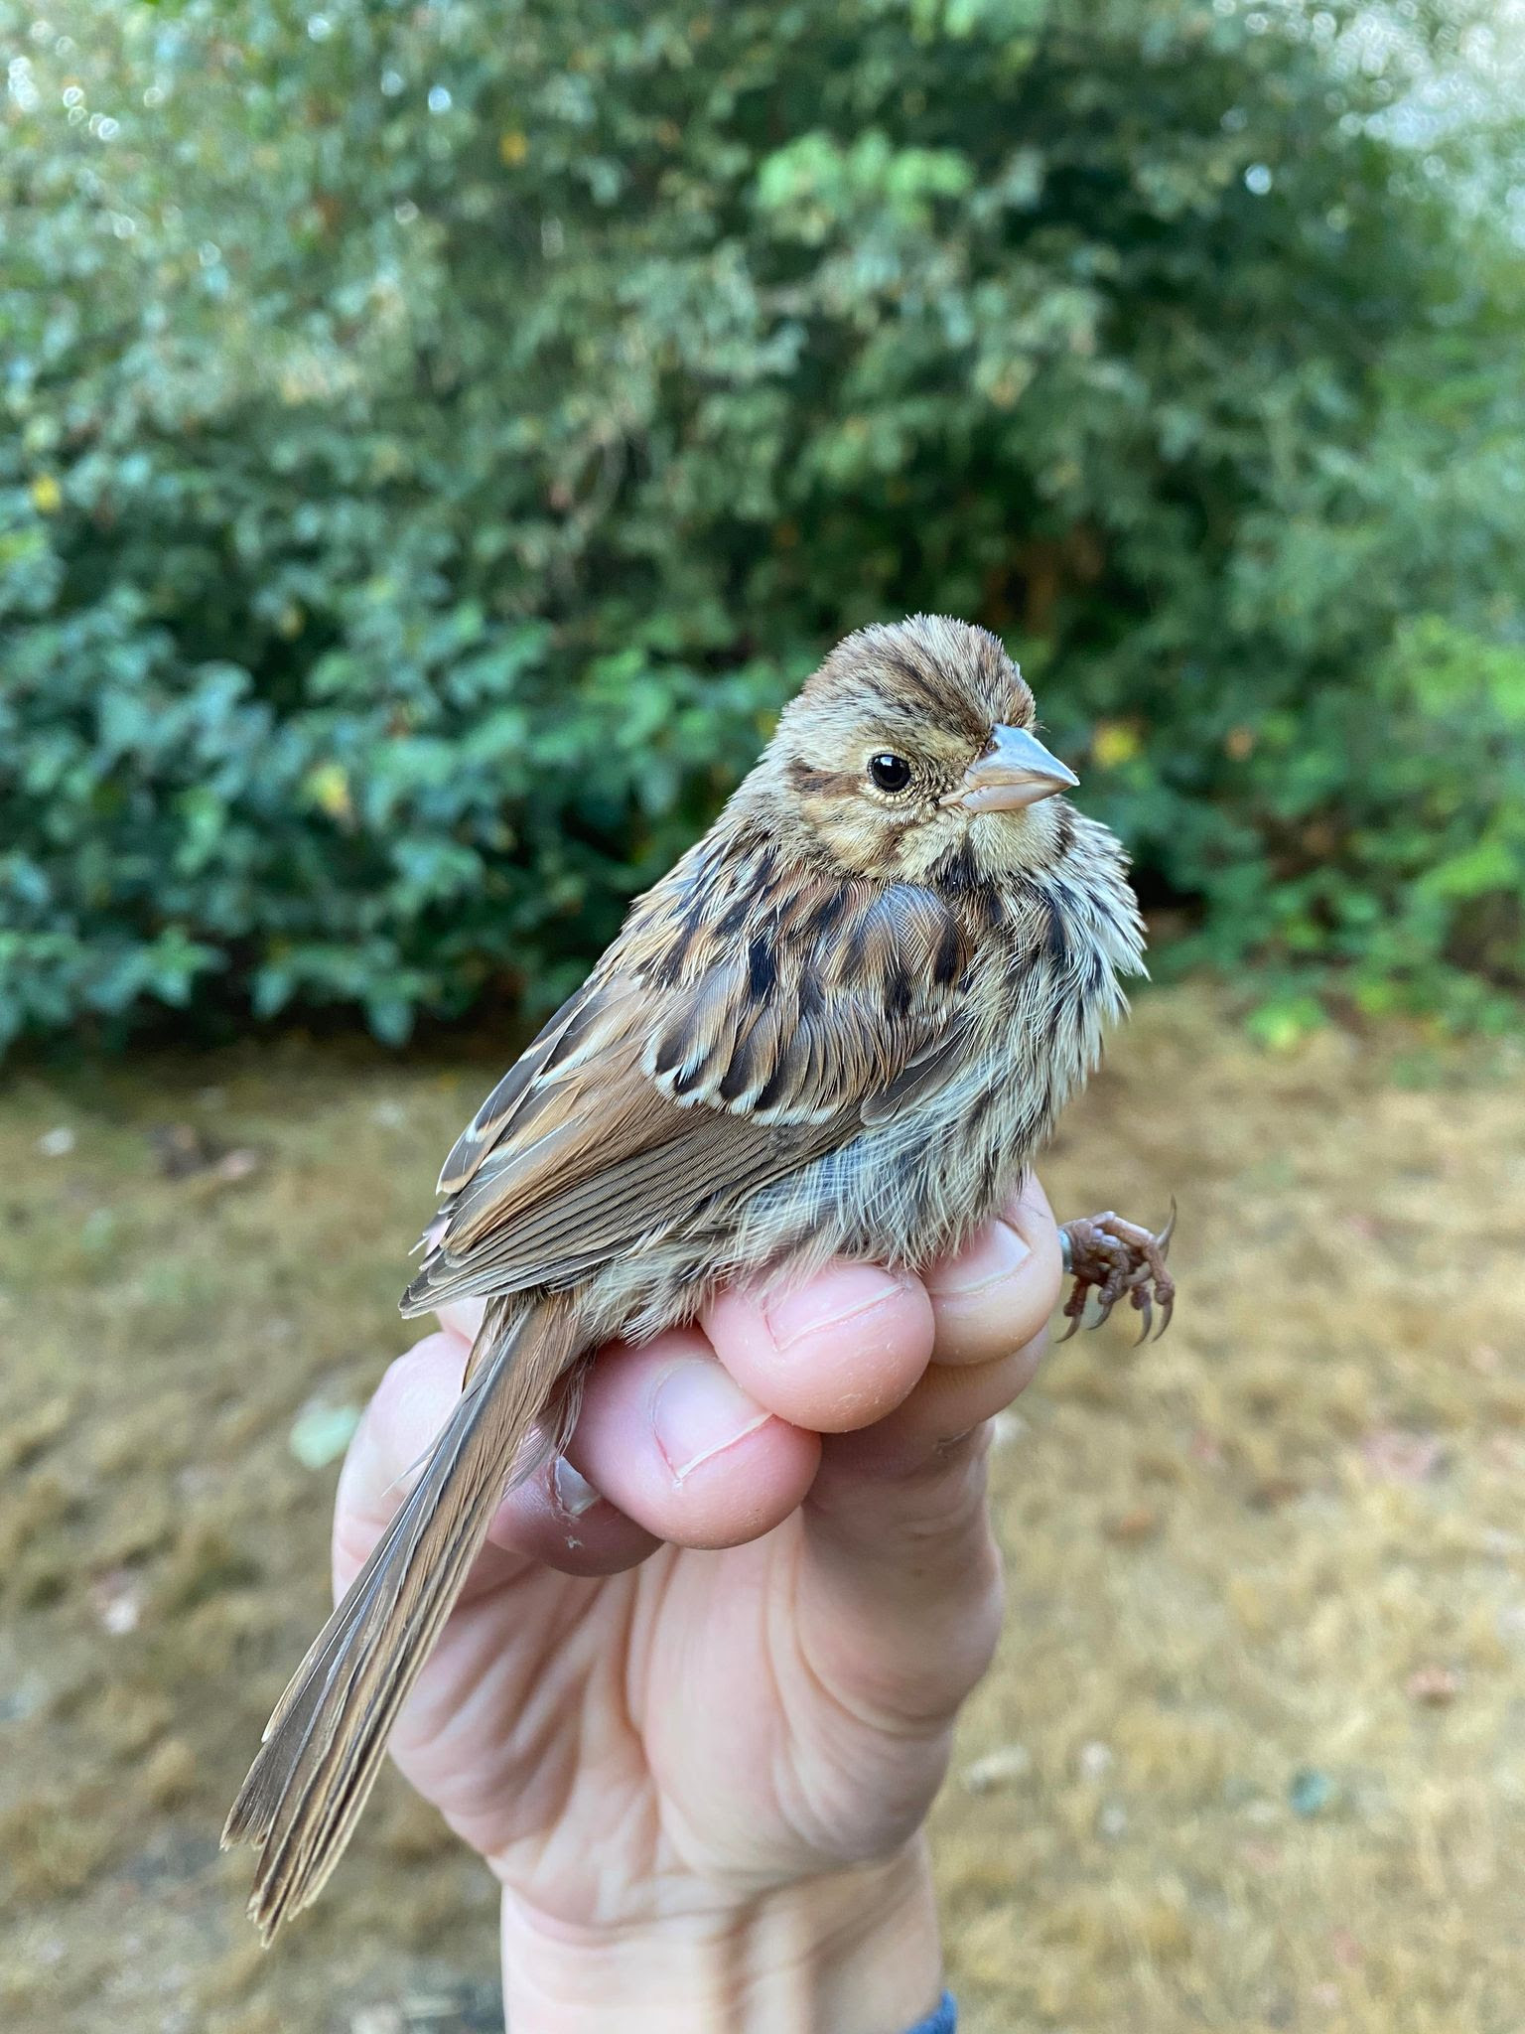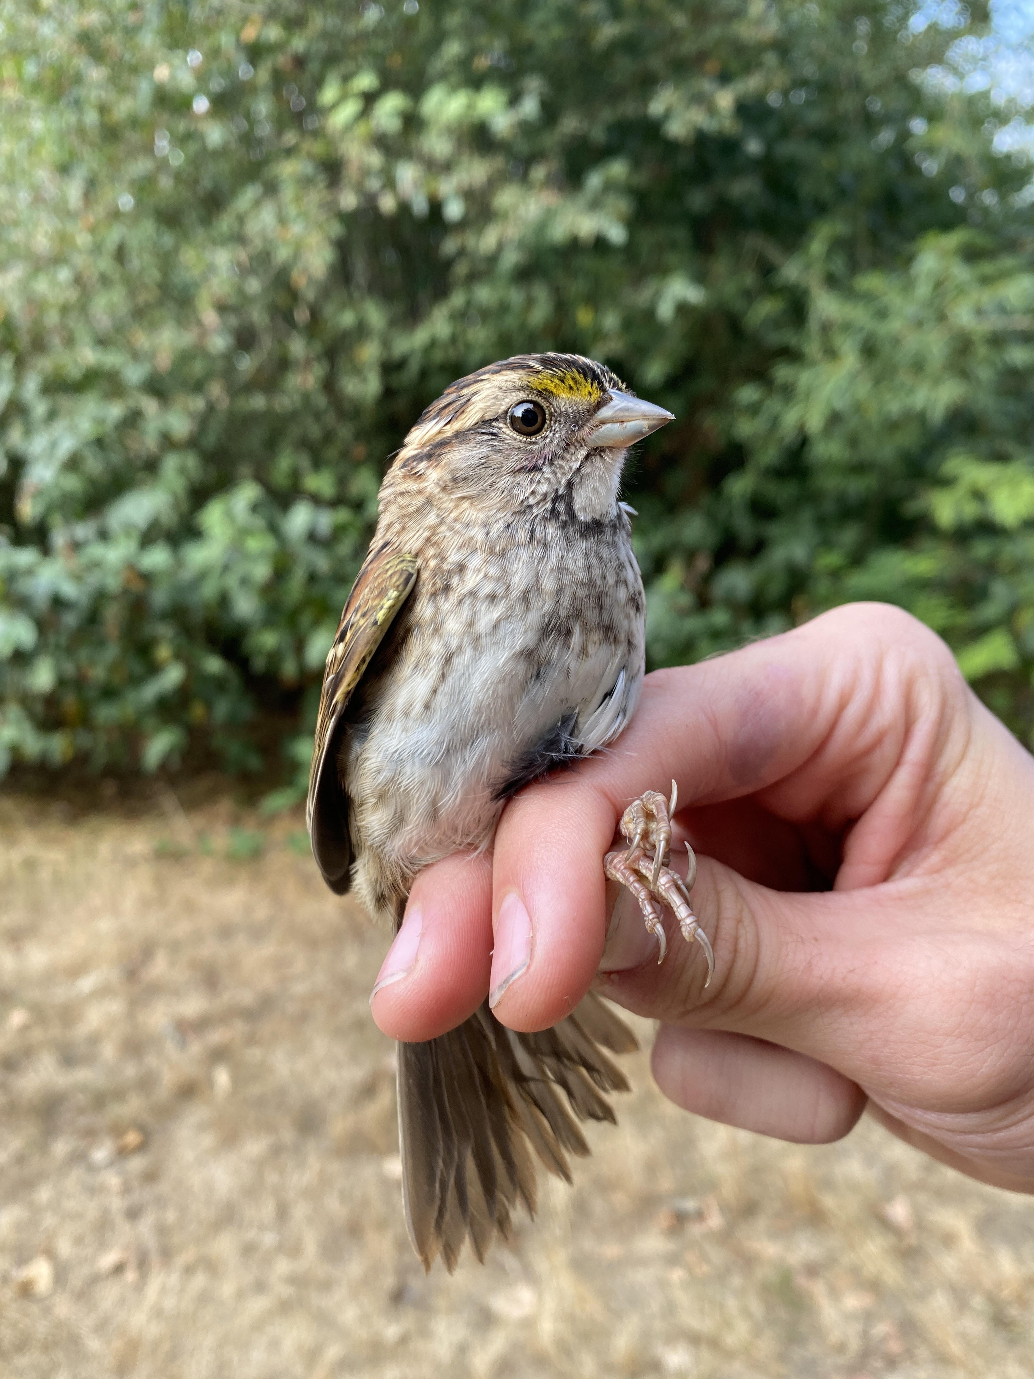
Likely interior subspecies of Song Sparrow (SOSP, left) and White-throated Sparrow (WTSP, right).
(Photo credits: Sean Vanderluit)

APPENDIX G

EQUITY, DIVERSITY, AND INCLUSION COMMITTEE 2022 REport

Chair:
Rotating
Members:
Kiirsti Owen, Secretary
Miki Eslake, Member-at-large
Kim Dohms, Member-at-large

G.1 Accomplishments
- Completed a Code of Conduct for the Iona Island Bird Observatory with input from banders.
- Provided Diversity & Inclusion training for all new board members and committee leads.
- Setup a sponsored membership option for those who wish to be a part of WildResearch but for whom the annual fee is prohibitive. Members can top up their member dues to donate to help “Sponsor a Membership”.

G.2 Expenses
- None.

G.3 Volunteer time
- 60 hours total (20 hours x 3 volunteers).

G.4 Next Steps
- Update website to include more information about current WildResearch EDI projects and initiatives.
- Work on increasing inclusivity and reach of WildResearch with underrepresented groups.

G.5 Challenges
- Capacity and meeting regularly. We could benefit from having one or two more volunteers and more regular meetings.

