MINUTES
WildResearch Annual General Meeting 2022
Date: February 26, 2022
Location: VanDusen Gardens and online via Zoom (hybrid event)
Start: 6:00 PM
In Attendance:
In person: Angela Bond (President), Florian Reurink (Treasurer), Quinn McCallum (Director at Large), Vinci Au (Director at Large), Matthias Bieber (Director at Large), Courtney Lahue (Director at Large), Viktorija Juciute (MSOC), Al Mckenzie, Thomas DeMarco, Sarina Clay-Smith, Paul Preston, Scott Wilson (MSOC), Danielle McLean, Kephra Beckett (MSOC), Murray Lashmar, Jillian Chiam, Ildiko Szabo, Illian Vakarelov, Julian Heavyside, Alexandra Welch, Saba Zarif, Chris Ensing.

Virtual: Kiirsti Owen (Secretary), Virginia Noble (Director at Large), Myles Lamont (Director at Large), Colin Macfarlane (MSOC), Donna McKenzie, Angela Hansen, Marina Thompson, Simon Valdez, Steacy (no last name provided), Siim (no last name provided).

Regrets: Devin deZwaan (Director at Large), Max Edworthy (Director at Large), Melanie Wilson (Director at Large)

Welcome and introductions – Angela Bond
- Meeting was called to order at 6:10 PM
- Welcome: brief introduction to the hybrid version

Adoption of Agenda – Angela Bond
Motion: to adopt the agenda.
Moved by: Al McKenzie
Seconded by: Thomas DeMarco
Decision: Motion carried unanimously

Approval of the minutes from the 2021 agm – Angela Bond
- Available at: http://wildresearch.ca/about-us/resources/
Motion: to approve the WildResearch 2021 AGM Minutes
Moved by: Al McKenzie
Seconded by: Viktorija Juciute
Decision: Motion carried unanimously

President’s report
- Presented by President Angela Bond
- See Appendix A for the full report

Treasurer’s report
- Presented by Treasurer Florian Reurink
- See Appendix B for the full report
Motion: to approve the WildResearch 2021 Treasurer’s Report
Moved by: Al McKenzie
Seconded by: Thomas DeMarco
Decision: Motion carried unanimously

Committee Reports
- BCMMP presented by Florian Reurink (see Appendix C)
- COHA presented by Angela Bond (see Appendix D)
- MSOC presented by Viktorija Juciute (see Appendix E)
- IIBO presented by Matthias Bieber (see Appendix
- EDI presented by Kiirsti Owen (see Appendix
- WESA presented by Devin deZwaan (see Appendix

Elections
- The following are WildResearch members stepping down from the Board of Directors for 2022:
  - President: Angela Bond
  - Director at Large: Virginia Noble
  - Director at Large: Max Edworthy
  - Director at Large: Courtney Lahue

- The following are WildResearch members being nominated for the Board of Directors for 2022:
  - Treasurer: Viktorija Juciute
  - Director at Large: Paul Preston
  - Director at Large: Sarina Clay-Smith

- The following are WildResearch members in good standing and are nominated for the positions listed on the Board of Directors for 2022:
  - President: Vinci Au
  - Vice President: -
  - Secretary: Kiirsti Owen
  - Director at Large: Florian Reurink
  - Director at Large: Myles Lamont
  - Director at Large: Melanie Wilson
  - Director at Large: Devin de Zwaan
  - Director at Large: Quinn McCallum
  - Director at Large: Matthias Bieber
Motion: to approve the 2022 nominations for the WildResearch Board of Directors
Moved by: Ildiko Szabo
Seconded by: Al McKenzie
Decision: Motion carried unanimously

Adjournment
Motion: to adjourn the 2022 Annual General Meeting
Moved by:
Seconded by:
Decision: Motion carried unanimously

Appreciation awards
**Note to all members, please keep these new appreciation awards in mind for future years. Any and all members can nominate any other member who deserves recognition for their contributions to WildResearch!**

Please join us after the meeting for our 12th Annual Volunteer Appreciation Party!

APPENDIX A

WildResearch President’s 2021 Report
Here we are, one year later, still navigating our way through this terrible pandemic. Who could have imagined? Yet, our Board and committees continued to persevere and rise to the challenge, resulting in a busy, productive, and highly engaging year for WildResearch and its members. Looking back at what we’ve accomplished, what we’ve offered, and the data we’ve collected, I can’t help but be so proud and grateful.
Covid still prevented us from holding indoor events, so our Membership Services and Outreach Committee (MSOC) focussed efforts on offering engaging and educational online events – most of which are very unique to WildResearch. Online workshops presented this year include Identifying Common Raptors in the Pacific Northwest, Bird Photography, How to Apply to Grad School in Ecology and the Environmental Sciences, Methods for Nocturnal Wildlife Surveys, and Identifying Common Shorebirds in the Lower Mainland. Our popular Winter Bird ID Field Trips were cancelled in early 2021 due to Covid, but I’m pleased to say they were back on this winter starting with Burnaby Lake in December, and continuing this January, February and March. The newsletter continued strong and was well-read, keeping us all informed of the exciting WildResearch happenings. The “Failed Field Folly” segment continued, and was changed to “Favourite Field Folly”, and a new highlight series was started for “Bird of the Month”. Many thanks to Jacqueline Huard for continuing to chair MSOC this past year.
This marked the first full year of our Equity, Diversity, and Inclusion committee (EDI), which formed in June 2020. They coordinated ensuring all Board members and committee leaders completed a course in Diversity and Inclusion Training for Volunteers. They are now working on a Code of Conduct to provide to all our members, as well as are working on revising language on our website and social media to be more inclusive. Many thanks to Kiirsti Owen for leading this.
We had another exciting year with our Western Sandpiper (WESA) Program, in collaboration with Environment and Climate Change Canada (ECCC). This year, we formed a Shorebird Operations Committee (SOC) to help run the program, which was overseen by Devin DeZwaan (thank you!). We banded in both Iona Beach Regional Park and Roberts Bank in the spring, then only in Iona for the summer sessions. We captured a total of 125 WESA and deployed 74 nanotags. We are hopeful this project will continue this year but this is not yet confirmed. There are other potential shorebird related projects in the pipeline with which we are also hoping to collaborate, so stay tuned!
On to our core programs, we were quite pleased to have the Cooper’s Hawk in the City (COHA) Program back again. This year had, by far, the highest record participation to date! 23 out of 24 quadrants were covered by 21 volunteers. There were 16 positive detections for COHA.
We launched our new BC Marsh Monitoring Program (BCMMP), in collaboration with Birds Canada in March. We started by holding an orientation workshop in February, led by both WildResearch and Birds Canada members, and was attended by over 200 people! Our volunteers conducted 197 amphibian surveys, 196 bird surveys, and 54 habitat surveys throughout 26 marshes. We were also honoured to be invited to provide training to the BC Wildlife Federation Wetlands Workforce on our marsh bird and amphibian survey protocols. They adopted these and also contributed to the wealth of data collected this year. New Bluetooth speakers were purchased for the purpose of using for call playback as part of these survey protocols; which are also used by the COHA program. A big thank you goes to Florian Renurik and Blake Danis for leading this.
Our flagship program, at Iona Island Banding Observatory (IIBO), operated for its twelfth season this year, still with Covid restrictions in place. This included installing a Plexiglass shield between the bander and scribe – many thanks to Julian Heavyside for this. We continued our daily census shift, also reaching out to Nature Vancouver members to assist with some of this shift coverage. Our hut maintenance continues to be a concern with a back wall that needs to be replaced due to water damage, and we are hoping to be able to do that this year, during the dry season between banding seasons. We did need to repair a broken window on the front of the hut this past fall.
We captured a total 4183 birds this year, with the top species being Wilson’s Warblers, Yellow-Rumped Warblers, and Song Sparrows. Some of the highlights include an Olive-Sided Flycatcher, Red-Eyed Vireos, Wilson’s Snipes, Black-Throated Grey Warblers, and what we believe is our first ever Grey Catbird. For Vancouver Bird Celebration Week, our participation was limited due to Covid, but we did do a social media blitz with live tweeting of updates from the station. We were not able to host groups in the spring, but we did take groups in the fall, including Darren Irwin’s UBC Biology class and the Vancouver Chapter of the Wildlife Society BC. We also hosted five international language bird walks, including Mandarin (thank you Andrew Huang) and Cantonese (thank you Vinci Au). A video was filmed at Iona this year as part of a series through the BC Bird Trail, highlighting what we do at the banding station. The series is meant to explore what makes BC a birdwatching paradise, and this short piece beautifully showcases what we do, giving us great exposure at the same time. Similar filming was also done for the BCMMP Program (not part of the BC Bird Trail series), which also looks fantastic. In the fall, we ran a pilot project for a potential Northern Saw-whet Owl monitoring program at Iona, and set up nets for a couple nights to see if there were enough NSWO to make it worthwhile. We didn’t catch any the first night, but were excited to capture 31 NSWO on the second night (27 of which we banded, 3 were recaptures, and 1 escaped from the net). This is a promising number and we are now looking into next steps for setting up a monitoring program, including banding and deploying motus tags. A huge thank you goes to this year’s Banders in Charge Brendan Toews and Max Edworthy, Assistant Banders Julian Heavyside, Simon Valdez, Maddie Edmonds, Emily Hood, and Quinn McCallum; and of course, our Program Manager Matthias Bieber.
Overall, we had a highly productive and exciting year. We offered a wide variety of online workshops, and hope we can soon start mixing in some in-person events now that Covid seems to be moving in the right direction. All of our programs and projects were in full swing, producing so much invaluable data, and fun! I sincerely hope you follow our newsletter and social media closely and participate in all that you can. Early spring is a very exciting and busy time with WildResearch (with BCMMP, COHA, and IIBO all starting up within a very short timeframe), and we can never have too many volunteers to help us! Lastly, it is with mixed feelings that I announce I am stepping down as President and from the Board of Directors, although I will continue to be heavily involved with WildResearch. Vinci Au will be taking over the President’s role and I am looking forward to the next chapter of WildResearch in her more than capable hands. I would also like to thank the following Directors at Large for all their years of service, who are also stepping down this year: Max Edworthy, Courtney Lahue, and Virginia Wiegand-Noble. And please join me in welcoming our newly incoming members: incoming Treasurer Viktorija Juciūtė, and incoming Directors at Large Paul Preston and Sarina Clay-Smith.

APPENDIX B

WildResearch Treasurer’s Report of 2021 Finance
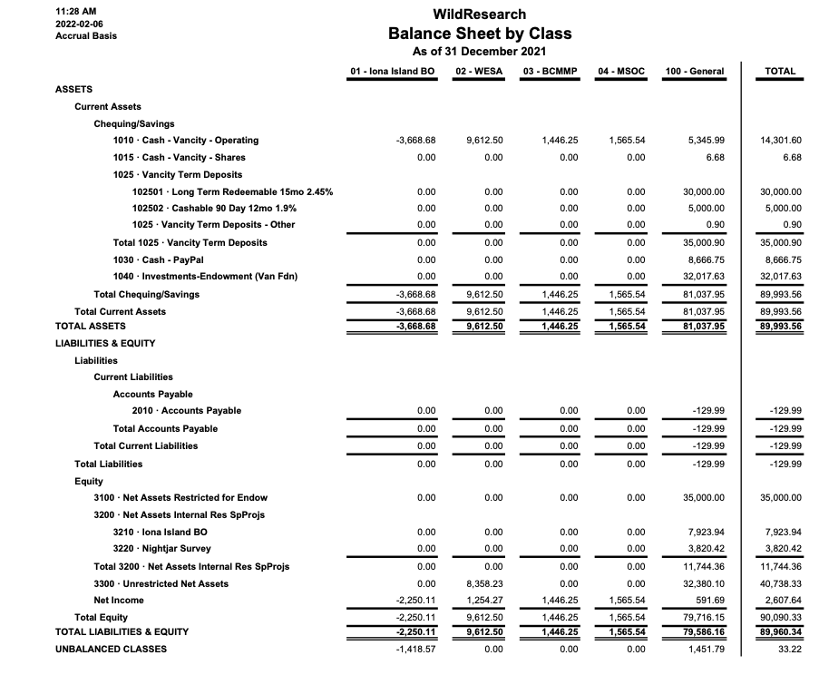

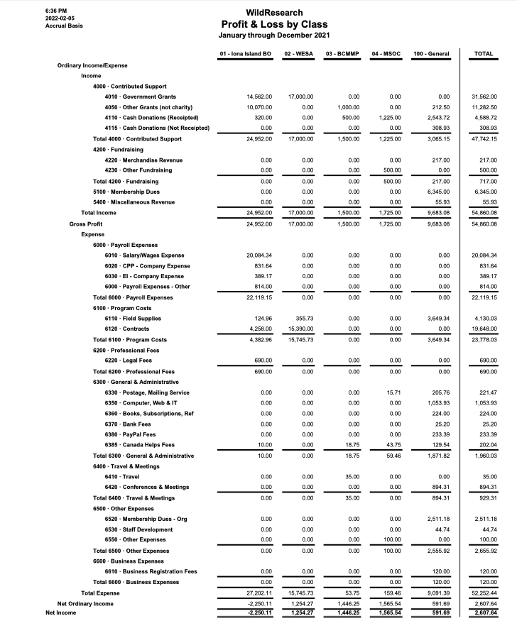

APPENDIX C

British Columbia Marsh Monitoring Program 2021 Report

C.1 Program Goals
The BCMMP contributes to all 3 organizational goals:
- Contribute to conservation science: The BCMMP collects presence and abundance data on 13 amphibian and 8 marsh-dependent bird species in wetlands throughout the Lower Mainland and Fraser Valley, with plans to expand throughout the remainder of BC. The amphibian species monitored include both species at risk and invasive species, while the target bird species rely on marsh habitat to breed. Data from the BCMMP is shared with Birds Canada and made available to interested parties upon request for use in research and to inform conservation efforts.
- Provide our members and partners with training and education in conservation science: The BCMMP provides volunteers with the skills to conduct passive call monitoring (for amphibian surveys) and targeted call-playback surveys (for bird surveys). Survey protocols, a recoding of the training workshop, and resources for learning how to identify amphibians and target bird species by call or song are all freely available through NatureCounts.
- Conduct conservation outreach: The BCMMP conducts outreach and education through a newsletter, which is sent out on a monthly basis throughout the survey period (Spring and early Summer) and bimonthly during the offseason. Furthermore, by combining bird and amphibian surveys, the BCMMP acts as a way for birders to learn about amphibian species in BC and their plight.

C.2 Season successes
Things that went well this season:
- For the inaugural year of the BCMMP, Volunteers conducted 197 amphibian surveys, 196 bird surveys, and 54 habitat surveys in 26 marshes throughout the Lower Mainland and Fraser Valley.
- BCWF and ECCC used BCMMP protocols to conduct an additional 296 bird surveys and 137 habitat surveys at various sites throughout BC.
- Over 200 people attended the BCMMP Workshop. The Workshop was recorded and is accessible online as a resource for volunteers to supplement guidebook protocols.
- We initiated the BCMMP Newsletter, which proved an effective tool for reaching and engaging our volunteer base (full credit here to Sarah Town).

C.3 Season challenges
Things that did not go as well this season:
- Pairing volunteers with marsh survey sites had to be done manually and required considerable effort from the BCMMP committee.
- Many survey sites in or near urban centers were very popular, but because of limitations on the number of surveyors per group, many volunteers in urban centers were unable to participate. Meanwhile, several remote survey sites went without surveys this year. Additionally, manual input made it difficult to reassign sites and locations to new volunteers/waiting volunteers.
- All survey forms needed to be reviewed and validated manually by BCMMP committee members. Due to the high volume of surveys, this required considerable time and effort. However, the process revealed several points of confusion with our protocols that we are clarifying for the 2022 survey period.

C.4 Summary of events
February 28 – BCMMP Workshop
BCMMP Workshop was held over Zoom with more than 200 people in attendance. The workshop was free to attend and consisted of a 1 hour introduction to the program from Florian Reurink (WildResearch) and David Bradley (Bird Studies Canada), followed by a 1.5 hour survey training session led by Blake Danis (WildResearch) and Graham Sorenson (Birds Canada). Participants were instructed on BCMMP protocols and identification skills for amphibian and target bird calls and songs.

March to July – Survey Period
BCMMP volunteers who signed up for marsh sites established survey stations and conducted surveys. Three amphibian surveys, two bird surveys, and a habitat assessment were conducted throughout the season at each survey station. Volunteers conducted surveys on their own schedules based on the BCMMP protocols. After conducting their surveys, volunteers uploaded their observations to the BCMMP NatureCounts portal.

August - December - Data Published to Avian Knowledge Network
BCMMP Committee members reviewed all the surveys submitted by volunteers and contacted volunteers to confirm any rare or unusual reports. Once all surveys had been validated, we published the data to the Avian Knowledge Network database. The data from the program is subject to a level 3 data sharing agreement, making it available to BirdsCanda for use in publicly available visualizations (i.e. maps and graphs). Additionally, the complete BC Marsh Monitoring Program data set is available upon request from the WildResearch Marsh Monitoring Committee for use in conservation, recovery, and scientific research.

C.5 Program Improvements & Future Outlook
Since this was the BCMMP’s inaugural year, we encountered several challenges that will be addressed prior to the 2022 survey season.
Our protocol handbooks need to be updated to include the expected distributions of various amphibian species to avoid the potential misidentification of species not known to be found in surveyors’ geographical areas. This is in progress and will be implemented by 2022 survey period.
An automatic system that allows volunteers to register for particular monitoring sites in NatureCounts would be easier and potentially more equitable for volunteers, and save the BCMMP committee countless hours of coordination time. Birds Canada is working on this, and changes to site selection procedures can be implemented by the 2022 survey period.
The BCMMP Committee has discussed creating a program that reimburses volunteers the cost of transportation to and from survey sites. This will lower the financial barrier for volunteers and facilitate volunteers in urban centers monitoring remote sites. We have obtained a grant from FWCP to begin to fund this program, but still need to develop a framework to determine eligibility and requests for reimbursement. This program will be implemented by the 2022 survey period.

C.6 Funding this past year
BC Hydro Community Giving Grant - $1000
Workshop BC Wildlife Federation Wetlands Workforce - $500
Fish and Wildlife Compensation Program Community Engagement Grant - $1000

C.7 Budget for next year
Income
Current BCMMP Account Balance | $2500
Total | $2500

Expenses
Employee to review survey data | $2000
Total | $2000

C.8 Volunteer hours
Volunteer surveyors: ~145 hours
BCMMP Committee members: ~500 hours

C.9 Personnel/Committee members
BCMMP Committee: Florian Reurink, Blake Danis, Sarah Town, Quinn McCallum, Gordon Hatusupy
Birds Canada: Graham Sorenson, Catherine Jardine, Rémi Torrenta

C.10 Collaborations
The BCMMP is itself a joint effort between WildResearch and Birds Canada. Birds Canada provides the protocols from the Great Lakes MMP upon which our protocols are based, our NatureCounts portal, liability insurance for our volunteers, and organizational support. The BCMMP would not be possible without Birds Canada.
The BCMMP collaborates with various local naturalist groups throughout BC, who conduct surveys at their sites using our protocols and submit their data to the project. These groups include the Stanley Park Ecology Society and the Wild Bird Trust.
In addition, Florian Reurink and Blake Danis provided training for BC Wildlife Federation Wetlands Workforce on the BCMMP marsh bird and amphibian survey protocols. The workshop was provided in person at the Silverdale Creek Wetland in Mission.

APPENDIX D

WildResearch Cooper’s Hawk 2021 Report

D.1 Program Goals
The Raptor Monitoring contributes to all 3 organizational goals:
- Contribute to conservation science: The data collected from the raptor monitoring program allows for changes in environmental conditions throughout the lower mainland to be observed by using a key indicator species of urban raptor, the Cooper’s Hawk (Accipiter cooperii).
- Provide our members with training and education in conservation science: The raptor monitoring program trains participants in how to conduct raptor surveys using protocols used by government and industry. The pre-season workshop provides educational material about the importance of the environmental pollutants and the effects on wildlife.
- Conduct conservation outreach: By providing this program to the general public, the raptor monitoring program shares with its participants the need for monitoring which will then be shared with their friends. As the surveys are completed throughout the urban area, occasionally people will stop to ask about the purpose of the call play-backs, providing more educational opportunities in real time.

D.2 Season successes
Things that went well this season:
- This season had the highest number of volunteers to date (21 volunteers). Previous highest number of volunteers in a season was 13 (2019). We had several new volunteers join the program this year.
- There was excellent coverage of quadrats this season; the highest number of quadrats covered to date (23 quadrats or 95.8%). Only one quadrat wasn’t covered.
- There were a good number of COHA reported (16 confirmed positive responses plus a few potentials), plus a couple detections outside survey times; between stations and during station set-up.

D.3 Season challenges
Things that did not go as well this season:
- Due to Covid-19, we were not able to hold an in-person outdoor orientation, and instead had to hold the orientations online via Zoom. It is more ideal to hold this outdoors when you can run through the protocol in person.
- The call-out for volunteers continued to be advertised after the orientation was complete and after the season started. We therefore scheduled more orientations for new volunteers well into the season, leaving less time to complete the survey. This was due to a communication issue. Going forward, advertising earlier and having an earlier orientation will work better to leave time for potential additional orientations if required, to be completed before the season starts. This did allow us to complete a higher number of quadrats, but made the first half of the season quite hectic.
- The one quadrat that wasn’t covered was assigned to a volunteer, and it wasn’t known that it wouldn’t be completed until after the season was over. Had we known earlier, we could have assigned that to another volunteer.
- We didn’t have any sort of post-season thank you gathering or gift this year. We haven’t done this any year but should try to implement going forward.

D.4 Summary of events
- All orientations were held online via Zoom due to Covid-19. The main orientation was on March 21, and two more were held on April 7 and April 12 for additional volunteers that either signed up later or couldn’t attend the first one. Eighteen volunteers attended the orientations this year. Surveys were conducted between March 28 and April 25.

D.5 Program Improvements & Future Outlook
- We would like to plan on having each quadrat surveyed twice per season – on any two different days within the survey period. This would not need to be done by the same person necessarily. One quadrat was surveyed twice this season. We will need to determine how best to implement this.
- We would like to start implementing some degree of nest monitoring of known active nests, but still need to plan out what this will look like.
- We would like to implement a post-season thank you event or gift for the volunteers that participated.

D.6 Funding this past year
- The program didn’t use any funding this year.

D.7 Budget for next year
- The board approved a budget of $200 per year for this program to use for volunteer appreciation.

D.8 Volunteer hours
- Approximately 95 hours for station set-up, survey completion, and data entry.

D.9 Personnel/Committee members
- The Program Co-Managers are Jay Brogan and Angela Bond, and there are no other committee members.

D.10 Collaborations
- No collaborations this year.

APPENDIX E

WildResearch’s Member Services and Outreach Committee 2021 Report

10 Members:
Jacqueline Huard, Chair/Treasurer
Vinci Au, Board Representative
Colin Macfarlane, Newsletter Coordinator, Newsletter coordinator
Viktorija Juciūtė, Newsletter Contributor, Newsletter coordinator & Membership Coordinator
Chloe Boynton, Member at Large,
Kephra Becket, Social Media Liaison

Angela Bond, Board Representative*
Kiirsti Owen, Social Media Contributor, Board Representative*
*Infrequent members

Sadly, we said good bye to Azim, Nisarg, and James. We welcomed two new members to our committee, Kephra, and Marina.

E.1 Committee Purpose
The Membership Services and Outreach Committee (MSOC) is all about the members! We manage the administration of members, events, and communication to members. WildResearch’s current membership as of December 2021 stands at 205 active members.

The MSOC oversees:
- Membership (registration, payment, insurance),
- Organizing the AGM & the Volunteer Appreciation Party (VAP),
- Merchandise,
- Fundraising,
- Committee finance planning & tracking,
- Outreach and general advertising,
- Newsletter production,
- Social media management and posting,
- Some e-mails/contact liaisons with members, and
- Planning, organizing and facilitating official WildResearch events and workshops.

Previously this committee was composed of two sub committees, the Outreach Committee and the Membership Services Committee. In 2019, they were joined together and are now known as the Membership Services and Outreach Committee (MSOC).

E.2 Committee Accomplishments
It has been another successful year for the MSOC. This year, in total we estimate that we raised $4,642.72 from events, donations, and general membership. We held 11 MSOC meetings, ran the newsletter, social media, conducted targeted and general outreach, and hosted or planned 10 events with participation by over 350 people (total). GO MSOC!
AGM
Similar to past years, the MSOC successfully planned and orchestrated the previous AGM (2021) on February 6th, our first ever all-digital AGM. This year’s AGM & VAP will be mixed in person & online at VanDusen Gardens on Feb 26, 2022.
Outreach
- Newsletter – This year we, again produced 33 newsletters with the help of 7 creators. Each newsletter requires 2 people to produce. Particular credit goes to Colin Macfarlane & Viktorija Juciūtė who stepped up this year as co-leaders of the Newsletter team bringing fresh new ideas and spunk, as well as to our past team lead Vinci Au who did a fantastic job seeing the new coordinators in and contributed to a significant number of the newsletters.

- Social Media – our presence has continued to increase with the ongoing help of Kephra, Hannah, and Wentao. Kiirsti and Vinci coordinated the hand off and did a fabulous job! We are now reaching:
  - Facebook: 1,870 Followers/1,766 likes
  - Twitter: 1,229 Followers;
  - LinkedIn: 195 Followers; and
  - Instagram: 1994;

- University Students – IN 2020 we created amazing posters but due to the pandemic we were never able to get them out. This fall we were able to post about 100 across Metro Vancouver. We visited UBC, libraries, cafes, pubic parks, and community centres. (4ppl X 2 Hours)

- We participated in a Giving Tuesday campaign in November and surpassed our goal and raised $1470
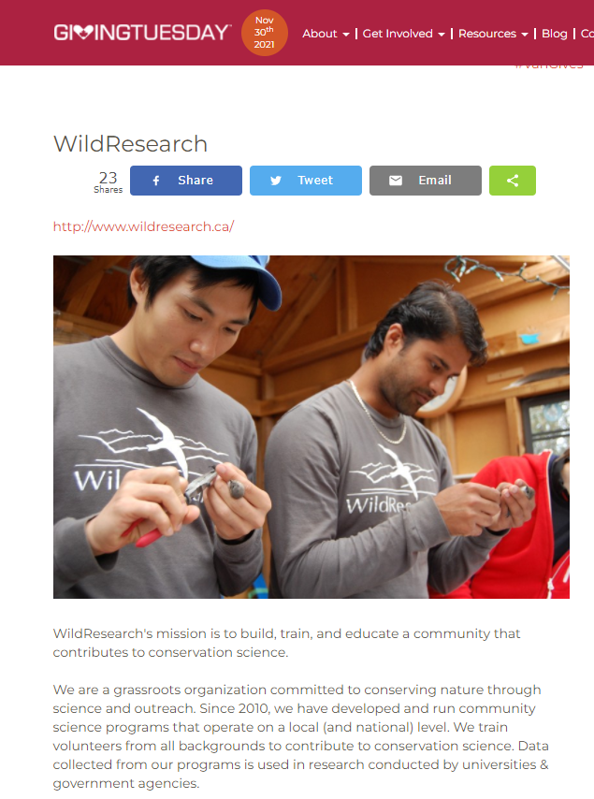
https://givingtuesday.ca/partners/wildresearch
- Demographics Survey – A survey to better understand who our members are, where they live, and what they’d like to get out of being members has been created. We will be delivering this to members in early February and collecting and processing the results in March.
- The BC Bird Trail (Jordan Stout) reached out to WildResearch in 2021 to coordinate and organize some collaboration on leading educations, awareness, and hyping up birding in BC. Together we were able to coordinate participation in a beautiful tourism/awareness related video with professional editing.
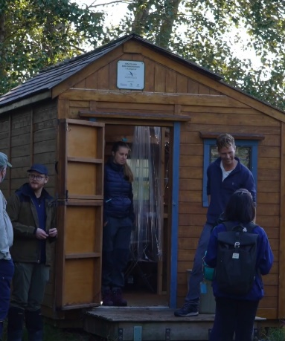
https://youtu.be/mpXE9rsiY94
Events
We held 6 events this year. And would have held more except that several were cancelled due to COVID.

- All socials were cancelled – But we have plans for 2022 social/speaker series!!
- An Introduction to the BC March Monitoring Program led by Florian Reurink, Blake Danis & Birds Canada, February 28th 2021 (150 attendees!)
- Raptor ID Workshop by Joachim Bertrands March 27th(144 attendees! - $540)
- Vancouver Bird Week (Cancelled)
- Bird Photography with James Mackenzie (41 attendees - $370)
- Common Shorebird ID with Joachim Bertrands (84 attendees - $500)
- Nocturnal Wildlife Survey Workshop (12 attendees - $140)
- Getting into Grad School workshop with Jakob Usinowicz (30 attendees)
- The 2021/2020 Guided Bird Walks have gone ahead
  - Dec 11th Led by Matthias at Burnaby Lake (organized with Kiirsti) (9 attendees)
  - Jan 9th Led by Chloe at Terra Nova
  - Feb 6th Led by Andrew at Maplewood Flats
  - March 12th Led by Chloe at Rifle

E.3 Volunteer time – 369 hours
This year due to the numerous events we facilitated, we hosted a meeting almost every month for a total of 11 this year (6 in 2019, 12 in 2020).
Regular Meetings: 11 meetings @ 1.5 hours each with 6 people ~ 100 hours
Non-meeting Outreach planning/organizing/delivering: ~15 hours
AGM planning/prepping outside of meetings: 25 hours
Social Media: 6hours/month (spread across 3 people) ~72 hours
Newsletter: 2 hours/week for 33 weeks * 2 people + training time ~ >132 hours
Processing memberships: 1.5 hours/month * 2 people ~ 25.5 hours
Total estimated hours: 369 hours (250 in 2019, 459 in 2020)

E.4 Finances
We successfully raised over $4,642.72 this year and spent only $97.34.
The total budget allocated to the MSOC in 2021 was $1,700.00, however 2020 presented an unusual spending year as COVID-19 restricted our ability to come together and therefore the need to rent space and supplies was not needed.
Total Spent: $358.16
- Venue rental: $0
- Food and drink: $0
- Serve-it-Right: $50
- Zoom Account: $100
- AhaSlides Account (for trivia): $78.16
- Event honorariums/gifts: $130
Recuperated costs: $5,056
- Merchandise: $150
- Brown Creeper/Giving Tuesday/general donations: $1,470
In addition to our existing inventory new mugs and buffs arrived early last year. We updated the photos on the website and made a concerted effort to advertise when opening our events. As our stock dwindles we will need to consider new orders.

E.5 Next Steps
The primary focus of the MSOC over the next 12 months include planning and executing the 2021 AGM and planning our spring events (See Table 1 below).
Table 1: Proposed 2022 WildResearch Events
Month | Count | Events
Jan | 1 | Guided Bird Walks,
Feb | 4 | Guided Bird Walks, AGM/Speaker/Trivia, Refresh: Marsh Monitoring, Backyard Bird Count, Pub Speaker Series/Socials
March | 5 | EDI/MSOC collab Meeting, Guided Bird Walks, Gull ID Talk & Field Trip (Joachim), Marsh Monitoring, Seedy Saturday, Socials
April | 2 | Spring Banding, Bird ID Workshop with Colin & Kiirsti, Intro to banding, MMP, Cooper’s Hawk MP
May | 3 | Spring Banding, Global Big Day, Skagit Bird Blitz, MMP, Fraser River Estuary Goose Impacts Tour
June | 2 | Doors Open Richmond, Manning Bird Blitz, MMP,
July | 1 | Nighthawk Surveys, Western Sandpiper Monitoring Program, MMP
Aug | 2 | Western Sandpiper Monitoring Program, Wings-Over-Iona
Sept | 1 | Fall Banding
Oct | 2 | Fall Banding, Vancouver Bird Week
Nov | 0 | TBD
Dec | 2 | Giving Tuesday, CBC
Total | 25/26 events!!

E.6 Challenges
Commitment requirements for the MSOC have remained steady but high. At times it can be difficult to plan the AGM while keeping up with other responsibilities including membership, the newsletter, emails, and duties from other committees/Board. We have had new committee members join as previous ones step away which brings new energy but takes time for folks to get trained up and up to speed.
As always, we are looking for additional members to distribute the work and gain new and diverse perspectives. This year Jacqueline Huard will be stepping down as Chair due to a busy upcoming schedule and therefore we will need a new chair, at this time no one has stepped forward.

APPENDIX F

Western Sandpiper Committee 2021 report

F.1 Program Goals
The Shorebird Monitoring program contributes to all 3 organizational goals:
- Contribute to conservation science: Data from the WildResearch shorebird monitoring program contributes to our understanding of how shorebirds use the Fraser Valley delta as stopover habitat during spring and fall migration, particularly fine-scale habitat use for Western Sandpiper (Calidris mauri); a species listed as a ‘Species of High Concern’ by US and Canada Shorebird Conservation Plans. Data collection is in collaboration with Environment and Climate Change Canada and contributes to the ongoing MOTUS project that continues to develop a telemetry network along the Pacific Coast to track migration dynamics. Additionally, data are being used in several PhD and MSc theses, as well as international collaborations within the Pacific Flyway Conservation Program.
- Provide our members with training and education in conservation science: The WildResearch shorebird monitoring program provides two distinct pathways for volunteers to get involved in casual citizen science initiatives, as well as more hands-on field training. Weekly shorebird surveys during migration allow volunteers to gain skills with shorebird ID and counting protocols. Nightly WESA capture events provide training for volunteers in targeted shorebird capture, extracting, handling, collecting biometric data, and deploying radio nanotags.
- Conduct conservation outreach: During shorebird surveys and capture events, volunteers are taught about the ecology of the species and the conservation relevance of better understanding migration dynamics. They also get to interact with government and university research scientists to expand their network. Our Shorebird Operations Committee has also been conducting outreach through social media to garner interest in the program.

F.2 Season successes
In the second season of the WildResearch Shorebird Monitoring program, we had a number of successes and improvements over the previous year. Firstly, we captured 125 Western Sandpiper and deployed 74 radio nanotags, nearly doubling our output from 2020. Secondly, we had 15 volunteers over the season, many of which who contributed multiple nights of their time during both migration seasons, as well as several additional volunteers who joined for the 22 shorebird surveys. Finally, we had more positive learning and training experiences during capture events, with more opportunities for discussion.

F.3 Season challenges
As expected in a field program, there were also challenges. We experienced real problems with volunteer burn-out and our ability to attract more volunteers due to the late hours. This led to volunteer shortages, particularly during Fall migration. Secondly, while there was an improvement over last year, we still received comments from some volunteers that they would like more hands-on training opportunities and they felt that the experience was not as advertised. This likely led to some of our issues retaining volunteer interest. Finally, Iona Island continues to be a difficult location to capture WESA, with only 25% of individuals capture at Iona compare to Roberts Bank, despite twice the number of capture events (effort).

F.4 Summary of events
Due to the ongoing COVID-19 pandemic, we did not have any events or workshops this year. However, we conducted 18 capture sessions and 22 shorebird surveys.

F.5 Program Improvements & Future Outlook
Following on from the previous section, one improvement for future years would be to generate more interest from the community and volunteers through targeted events. While we already hold a shorebird ID workshop sometimes, this could be more directly associated with the Shorebird Monitoring program and double as a recruitment event. We could also hold a shorebird trivia night (online or in person) and consider additional events that show appreciation for all of the volunteers’ hard work (e.g., end of season get together). The future of this program is uncertain as it is not clear whether the contract with ECCC will continue for a third year. We have also looked into expanding the program to involve collaborations with Birds Canada and other shorebird research projects in the area (e.g., Dunlin migration monitoring; shorebird microplastic study). However, the status of our involvement in these programs are pending.

F.6 Funding this past year
Through our contract with ECCC, we received a total of $20,000.

F.7 Budget for next year
An additional year will require a renewed contract with ECCC.

F.8 Volunteer hours
In total, volunteers contributed approximately 441 hours to WESA capture and 220 hours to the shorebird survey.

F.9 Personnel/Committee members
The WildResearch Shorebird Monitoring program would have not been possible this year without the new Shorebird Operating Committee (SOC) which handled day-to-day organization, field work, and volunteer recruitment. The Shorebird Operating Committee was made up of Alexandra Welch, Claudia Shaughnessy, and Kendra Bisbing. Myles Lamont also contributed extensively to the program as oversight for the SOC and for multiple capture events. Eve Fernandez and Simon Valdez acted as the Bander-in-Charge and Assistant Bander-in-Charge respectively, while Brendan Toews led most of the shorebird surveys. Finally, Matthias Bieber ensured banding and capture materials were available and Devin de Zwaan acted as program lead.

F.10 Collaborations
The Shorebird Monitoring program involves collaborations with Environment and Climate Change Canada, specifically Mark Drever and Scott Flemming. Data collection was also in collaboration with Chris Guglielmo’s lab at Western University.

F.11 Other
N/A

APPENDIX G

WildResearch Equity, Diversity, and Inclusion Committee 2021 Report

G.1 Program Goals
The Equity, Diversity, and Inclusion (EDI) Committee is dedicated to creating space in WildResearch and community science for a diversity of people by improving inclusion and accessibility in our organization.
The EDI Committee contributes to all 3 organizational goals:
- Contribute to conservation science: The EDI Committee encourages accessibility in all of WildResearch’s programs so that people from all backgrounds and identities can participate in conservation science.
- Provide our members with training and education in conservation science: The EDI Committee administers the Diversity & Inclusion training for board members and programs leads. In the future, we would like to provide education and training opportunities related to equity, diversity, and inclusion to members as well.
- Conduct conservation outreach: The EDI Committee hopes to include outreach in our future endeavours focused on improving equity, diversity, and inclusion in our conservation community.

G.2 Season successes
Things that went well this season:
- It was our first year as a new committee in WildResearch
- We administered online diversity and inclusion training for all board members and program leads
- We began work on a Code of Conduct document for WildResearch

G.3 Season challenges
Things that did not go as well this season:
- As a small committee, we struggled to meet regularly during the summer
- We had to postpone some of our deadlines for training and Code of Conduct completion

G.4 Summary of events
Not applicable – the EDI Committee hopes to host events in the future or be involved in events hosted by other programs or committees!

G.5 Program Improvements & Future Outlook
- Implement new action items based on feedback from the Diversity and Inclusion Training – Work in progress. We have several action items that we hope to tackle in 2022.
- Create a Code of Conduct for WildResearch that can be shared with all volunteers and members, along with a reporting process for members who experience something that they feel does not align with the Code of Conduct – Work in progress. We would like to hire a facilitator who has experience helping non-profits develop Codes of Conduct.

G.6 Funding this past year
None.

G.7 Budget for next year

Code of Conduct development, hiring a facilitator | $700.00
Total | $700.00

G.8 Volunteer hours
3 volunteers x 2 hours/month = 72 hours

G.9 Personnel/Committee members
Kiirsti Owen, Kim Dohms, Miki Eslake

G.10 Collaborations
None, but we have discussed having regular meetings with MSOC to collaborate on events and different projects.

G.11 Other
If anyone is interested in joining the EDI committee, they can contact Kiirsti at info@wildresearch.ca

APPENDIX H

WildResearch Iona Island Bird Observatory 2021 Report

Program Goals
IIBO contributes to all 3 organizational goals.
- Contribute to conservation science: IIBO determines the abundance and diversity of migrants that use the Iona Beach Regional Park (hereafter: Iona) as a stopover site; IIBO monitors the arrival dates of spring and fall migrants and the departure dates of birds that migrate north to breed or south to overwinter.
- Provide our members with training and education in conservation science: IIBO provides a positive learning environment for volunteers, encouraging the developing of field ornithology skills (e.g. species ID, banding, extraction from nets).
- Conduct conservation outreach: To maintain a focus on public education and outreach on avian conservation via on-site demonstration and social media.

Season successes
Breakdown of # of species and individuals caught
Total # of birds captured: 4183 (3423 banded, 659 recaps, 101 unbanded)
- Spring:
  - 1771 total captures: 1405 banded, 278 recaps, 88 unbanded (mostly hummers)
  - Over 37 days (10 weather days); 2474 net hours
    - ~48 Birds/day
    - 0.72 birds/net hr
  - Compared to previous years
Year | Total Captures | Birds/net hr
2015 | 1476 | 0.58
2016 | 1232 | 0.44
2017 | 2806 | 1.43
2018 | 2197 | 0.66
2019 | 2858 | 0.92
2020 | N/A | N/A
  - 42 species banded and 26 species recaptured
  - Most abundant banded:
Species | Number Banded
WIWA | 290
MYWA | 207
AUWA | 178
OCWA | 92
RCKI | 80
  - Interesting Highlights
    - Rarities: OSFL
    - Other good birds: 2 WISN, VATH, 2 BTYW
- Fall:
  - 2448 total captures: 2018 banded; 417 recaps; 13 unprocessed
  - Over 29 days (13 weather days); 1518.7 net hours
    - ~85 birds/day
    - 1.62 birds/net hr (2nd highest rate!)
  - Compared to previous years:
Year | Total Captures | Banding Days | Birds/net hr
2015 | 1476 | 22 | 0.35
2016 | 1232 | 22 | 1.05
2017 | 2806 | 29 | 1.12
2018 | 3509 | 35 | 0.95
2019 | 4192 | 38 | 2.02
2020 | 2272 | 37 | 1.03
- 45 species banded and 26 species recaptured
- Most abundant banded:
Species | Number Banded
YEWA | 848
SOSP | 191
MYWA | 118
AUWA | 98
OCWA | 89
  - Interesting highlights
    - Rarities: GRCA (first ever?), NOWA, 2 REVI, 2 WTSP
    - Also BTYW, TOWA, 2 VATH (more common but rarely captured)
Breakdown of volunteer contribution and visitors
Total # of volunteers and volunteer hours:
- Spring: 31 different volunteers, 81 volunteer days, 572.5 hours
- Fall: 35 different volunteers, 68 volunteer days, 473.5 hours
- More hours than 2020 but fewer than 2019 and 2018
Education & Outreach Program
- Total: 573 (Spring: 317, Fall: 256) people visited IIBO
  - Reduced group visits in spring due to covid-19
- Social media blitz for Vancouver Bird Week in May
- Group visits:
  - Fall: 5 international language bird walks, UBC university group, Tupper Charles high school group and Wildlife Society of BC – 113 people total
  - Also 2 visits by videographers for promotional videos (WR and BC Bird Trail)

Banding Workshops – Canceled in 2021

Other Exciting Things
NSWO Pilot Monitoring Program
- Initiated a few nights of NSWO banding in late fall to test potential for a full owl monitoring program and MOTUS tagging with good success! We banded 27 NSWO in a single night in late October.
CWS Collaboration: Feather collection for stable isotope analysis (cont’d)
- Investigating breeding origins of species that experience high window collision mortality during migration and in winter in SW BC
  - FOSP, GCSP, SOSP, HETH, WCSP
- Through this IIBO is helping to increase understanding of migratory connectivity between breeding and non-breeding populations for these species, and the contribution of winter mortality to their declines
Feather collection for the Bird Genoscape Project
- Started collecting feather samples for the Bird Genoscape Project for the Center of Tropical Research out of UCLA for the following species: AMRO, MGWA, WETA, COYE, WIFL, WIWA and YEWA
Shorebird Banding Collaboration with ECCC (cont’d from 2020)
- IIBO bander, Simon Valdez Juarez helped capture and apply nanotags to Western Sandpipers on Iona Beach and Roberts Bank in April, July and August. IIBO also lent equipment for this.

Season challenges
- Banding with COVID for a second season
  - Protocols established last year helped make this relatively smooth
  - Reduced effort in spring (one beginner), back to normal in fall
  - Broken window fixed and plexiglass barrier installed btw scribe and bander
- Hiring new banders – high turnover with banding assistants
- Funding for salary – CSJ does not fund multiple positions for same employee in one year
- Getting intermediate/ advanced and census volunteers and to help, especially in fall when busy
- Equipment mix ups with WESA program
- Need more support with program management to advance the program
- Banding hut still has a leak
- Lost many days to bad weather, especially in fall

Suggestions for how program can be approved (in correspondence to the 3 bullet points above):
- Continue updating covid protocols as pandemic situation progresses
- Start looking for banders earlier, advertise to broader audience
- Look for alternative funding sources
- More advertisement on social media, email reminders to skilled volunteers, ask BC Nature volunteers for help with census
- Form a program committee with at least 3 members
- Fix the hut btw spring and fall seasons – get Alan involved.
- Use sign out system to track equipment or have WESA program acquire their own banding tools

Other things

2021 grants received:
- Canada Summer Jobs (Service Canada) – $12,064
- Port of Vancouver (Vancouver Fraser Port Authority) - $10,000

What’s going on in 2021?
- Spring and fall banding seasons, banding workshops (covid allowing)
- NSWO Fall Monitoring and MOTUS tagging
- More feather sample collection for the Bird Genoscape Project

Budget for 2021
- Salary: $24,444
  - Spring: Employees: $10,029, Contractors: $2,590
  - Fall: Employees: $10,317, Contractors: $1,508

